Georgia Mountains Healthcare Coalition
Regional Active Threat Exercise (Active Shooter / and Burn Surge) Tabletop Exercise
May 24, 2022
After Action Report
Improvement plan
Published: June 15, 2022

Note: This After Action Report (with included Improvement Plan Appendix) aligns selected exercise objectives with preparedness doctrine to include the National Preparedness Goal and related frameworks and guidance.

Findings in this report are based upon observations of exercise facilitators and evaluators in addition to feedback provided by exercise participants.

Contents
Contents 3
Handling Instructions 4
Exercise Overview 5
Exercise Planning and Participation 6
Exercise Planning Team (EPT) 6
Participating Organizations 6
Number of Attendees 7
Tabletop Exercise Planning and Preparation 7
Executive Summary 8
Regional Analysis of Core Capabilities 11
Summary of Core Capability Performance 12
Appendix A: Improvement Plan Worksheet 19
Appendix B: Georgia Mountains Healthcare Coalition Communications Coordination Plan 22
Appendix C: Georgia Mountains Healthcare Coalition Executive Committee Contacts 24
Appendix D: Georgia Mountains Healthcare Coalition Facility Bed Counts 25
Appendix E: Acronyms 26
Appendix F: Regional Coordinating Hospital Area Map 27
Appendix G : Public Health Districts Map 28
Appendix H: Emergency Medical Service Regions Map 29
Appendix I: GEMA Regions Map 30
Appendix J: Georgia Health Care Association Council Map 31
Appendix K: GAPHC Community Health Centers Map 32
Appendix L: GDBHDD Regional Map 33
Appendix M: Role of Specialty Coordinating Hospital 34
Appendix N: GMHC BURN ANNEX 35

Handling Instructions
The title of this document is Georgia Mountains Healthcare Coalition Active Threat (Active shooter and Burn Surge) Tabletop Exercise (TTX) After Action Report (AAR).
The information gathered in this AAR is For Official Use Only and should be handled as sensitive information not to be disclosed. This document should be safeguarded, handled, transmitted, and stored in accordance with appropriate security directives. Reproduction of this document, in whole or in part, without prior approval from the Georgia Mountains Healthcare Coalition EPT, or the Georgia Mountains Healthcare Coalition Regional Coordinating Hospital, Northeast Georgia Health System, is prohibited.
For more information, please consult the following points of contact:
Name | Phone | Email
Georgia Mountains Healthcare Coalition RCH Northeast Georgia Health System
Matthew Crumpton, NRP, MEP, CEM-GA, EMHP  Emergency Preparedness Manager  Georgia Mountains Healthcare Coalition Coordinator | Mobile: 678.630.5955  Office: 770.219.1823 | Matthew.Crumpton@nghs.com
Frances Franks, BSN, RN, EMHP  Intensive Care Charge Nurse  Coalition Clinical Advisor | Mobile: 334.444.2651 | Frances.Franks@nghs.com

Exercise Overview
Exercise Name | Georgia Mountains Healthcare Coalition –Regional Active Threat (Active shooter and Burn Surge) Tabletop Exercise
Exercise Date | May 24, 2022
Scope | This discussion-based exercise focuses on Georgia Mountains Healthcare Coalition healthcare facilities’ and community partners’ ability to respond to a regional active shooter / burn surge event. This will include reviewing local and regional response plans, as well as engaging in discussion to address potential gaps that may exist.
Mission Areas | Prevention, Protection, Mitigation, and Response
Core Capabilities | - Capability 2: Health Care and Medical Response Coordination  Objective 1: Develop and Coordinate Health Care Organization and Health Care Coalition Response Plans  - Capability 4: Medical Surge  Objective 1: Plan for a Medical Surge  Objective 2: Respond to a Medical Surge
Objectives | - Review regional and internal plans, policies, and procedures of The GMHC Region’s healthcare facilities and community partners needed to respond to a regional active threat event;  - Review communications plans involving incident notification and ongoing situational awareness among area healthcare facilities, local governments, and regional partners  - Review internal surge plans  - Review agency/facility role in a burn mass casualty incident.  - Validate assumptions in the HCC Burn Surge Annex.  - Review existing burn care assets and identify gaps that may occur in a burn-related mass casualty incident.
Threat or Hazard | Active shooter in Medical Facility resulting in trauma and burn surge
Scenario | A landscaping crew notices a red Ford Mustang approach the medical office building at an  accelerated speed and park illegally in front of the building. A white male exits the vehicle dressed in blue jeans and a red flannel shirt. Upon exiting the car, he reaches into the backseat and pulls out a black backpack and is soon observed entering the medical office building through the front door. A front seat passenger appears to move over to the driver’s seat.  Shortly after the male enters the building, the landscaping crew hears loud screams and “popping noises” similar to gun shots coming from inside the medical office building. Several visitors and patients are then seen fleeing the building. After several minutes, the gunman exits the building and gets back in the red Ford Mustang, which leaves the scene at a high rate of speed.
Sponsors | Georgia Mountains Healthcare Coalition, Northeast Georgia Health System Regional Coordinating Hospital; Georgia Department of Public Health
Participating Organizations | 45 Participating Healthcare Organizations and Community Partners (see page 6 for complete listing)

Exercise Planning and Participation

Exercise Planning Team (EPT)
Representatives of the following organizations participated in the Georgia Mountains Healthcare Coalition Tabletop Exercise planning process by attending scheduled regional exercise planning meetings:

- District 2 Public Health
- Northeast Georgia Health System

Participating Organizations
The following organizations were represented at the Georgia Mountains Healthcare Coalition Tabletop Exercise:

- Acts Retirement Life Communities Lanier Village Estates
- Air Methods Georgia
- Amerimed EMS
- Banks County Fire and Emergency Services
- Barrow County EMA
- Braselton Endoscopy Center
- Brown Health and Rehabilitation
- Chatuge Regional Hospital
- Chatuge Regional Nursing Home
- Chelsey Park Health and Rehabilitation
- Encompass Health and Rehab
- Fulton County Board of Health
- Friendship Health and Rehab
- Gainesville Endoscopy Center
- Gateway Health and Rehab
- Georgia Department of Public Health
- Georgia Department Public Health District 2
- Georgia Department Public Health District 3-2
- Georgia Department Public Health District 3-4
- Georgia Emergency Management Agency /Homeland Security
- Georgia Health Care Association
- Georgia Mountains Healthcare Coalition
- Georgia Mountains Health Services, Inc
- Habersham Medical Center
- Hall County 911/EOC
- Hall County EMA
- Hospice of NGMC
- The Landings of Gainesville
- Lumpkin County EMA
- Medlink Georgia – Inc.
- New Horizons Lanier Park
- New Horizons Limestone
- Northeast Georgia Medical Center - Barrow
- Northeast Georgia Medical Center - Braselton
- Northeast Georgia Medical Center – Gainesville
- Northeast Georgia Medical Center – Laurelwood
- PruittHealth Home Health - Gainesville
- Pruitt Health - Hospice
- PruittHealth-Toccoa
- Specialty Orthopaedics Surgery Center
- Specialty Spine and Pain
- Stephens County Hospital
- Suncrest Home Health
- Union County Nursing Home
- Union General Hospital
- University of Georgia - IDM
- University of North Georgia
- UNG, Police Department
- Viewpoint Health

Number of Attendees
Number of Attendees
Logistics/Support………………………………….3
In person Participants………………………….…….…51
Virtual Participants……………………………………….19
TOTAL: 73 attendees

Tabletop Exercise Planning and Preparation
In preparation for the exercise, the following meetings were held:
January 21, 2022 Tabletop Exercise Concepts & Objectives (TTX C&O) & Tabletop Exercise Initial Planning Meeting (TTX IPM)
February 16, 2022 Tabletop Exercise Midterm Planning Meeting (TTX MPM)
March 14, 2022 Tabletop Exercise Final Planning Meeting (TTX FPM)

Executive Summary
The Georgia Mountains Healthcare Coalition Active Threat (Active shooter and Burn Surge) Tabletop Exercise was held on May 24, 2022 at the Lanier Technical College Ramsey Conference Center in Gainesville, Georgia. The 73 participants included representatives from many coalition healthcare facilities, local community response partners, and state and regional support agencies. The Georgia Mountains Healthcare Coalition tabletop exercise focused on the coalition’s ability to respond to an active shooter / burn surge at a medical facility and subsequent burn surge scenario affecting healthcare facilities and their partners across the region. Tabletop participants were seated with county partners in order to facilitate discussion of both local and regional plans. The exercise sought to identify gaps in capabilities that currently exist in both local response plans and the Georgia Mountains Healthcare Coalition’s Communication Coordination Plans, as well as the response and burn annexes.
The following areas were recognized as major strengths of the Georgia Mountains Healthcare Coalition healthcare coalition during the exercise:
- Most represented facilities and agencies noted having Emergency Operations Plans (EOPs) available and were familiar with the triggers for plan activation and implementation.
- Most represented facilities have existing Memoranda of Understanding (MOUs) with other agencies, including private corporations, to help procure additional supplies during an event.
- All participating groups were very cognizant of their specific vulnerabilities at each respective agency.
- Most facilities have many forms of redundant communications available for emergencies.
- Some coalition members are aware of resources and training available through the coalition such as CISM, TECC, Stop the Bleed education.
The primary identified regional opportunities for improvement were as follows:
- Though GMHC has a regional communications coordination plan, some coalition members remain unclear on their specific roles within the plan and how regional coordination would be achieved during a widespread event, especially one of this nature.
- Communication with patients/clients, employees, families, and the public was identified as a key opportunity for improvement; especially with noted language barriers.
- Many facilities are not aware of the resources available to the Georgia Mountains Healthcare Coalition Unified Coalition during a disaster/emergency
- Many participants recognized the need for more awareness and training regarding burn specific triage, care, and transportation.

Objective | Core Capability | Discussed with No Gaps Identified (N) | Discussed with Some Gaps Identified (S) | Discussed with Major Gaps Identified (M) | Unable to be Discussed (U)
- The Georgia Mountains Healthcare Coalition will review regional and internal plans, policies, and procedures of The GMHC Region’s healthcare facilities and community partners needed to respond to a regional active threat event; | Health Care and Medical Response Coordination |  | S
- The Georgia Mountains Healthcare Coalition will review communications plans involving incident notification and ongoing situational awareness among area healthcare facilities, local governments, and regional partners. | Health Care and Medical Response Coordination |  | S
- The Georgia Mountains Healthcare Coalition members will request, mobilize, and demobilize regional and/or state assets during an active shooter/burn surge response in accordance with regional plans and protocols. | Health Care and Medical Response Coordination |  | S
- The Georgia Mountains Healthcare Coalition healthcare facilities and response partners will review internal surge plans and individual agency/facility role in a burn mass casualty incident. | Medical Surge |  | S
- The Georgia Mountains Healthcare Coalition will validate assumptions in the HCC Burn Surge Annex and review existing burn care assets and identify gaps that may occur in a burn-related mass casualty incident. | Medical Surge |  | S
Ratings Definitions:
- Discussed with No Gaps Identified (N): The targets and critical tasks associated with the capability were discussed in a manner that fully addressed the objective(s) without identifying any operational gaps in current policies, plans, and protocols. Existing policies, plans, and protocols are effective and are not perceived to need additional updates at this time. Staff members are fully trained and understand the existing protocols.
- Discussed with Some Gaps Identified (S): The targets and critical tasks associated with the capability were discussed in a manner that addressed the objective(s). While plans are currently in place, some operational gaps were identified. Plans need to be expanded and/or altered to better address identified gaps. Additional training and education on existing plans may also be required.
- Discussed with Major Gaps Identified (M): The targets and critical tasks associated with the capability were discussed in a manner that addressed the objective(s). It was recognized that major operational gaps are present. Needed plans, policies, and protocols may not exist. Current plans are not coordinated with coalition partners and will be difficult to effectively operationalize during a regional response. Training and education on any new plans or protocols will be required.
- Unable to Discuss (U): The targets and critical tasks associated with the capability were not discussed in a way which allows for evaluation of the identified objective(s).

Regional Analysis of Core Capabilities
Aligning exercise objectives and core capabilities provides a consistent taxonomy for evaluation that transcends individual exercises to support preparedness reporting and trend analysis. Table 1 includes the exercise objectives, aligned core capabilities, and performance ratings for each core capability as observed during the exercise and determined by the evaluation team.

Summary of Core Capability Performance

Analysis of Exercise Objectives
The following sections provide an overview of the performance related to each exercise objective and associated core capability, highlighting strengths and areas for improvement.

Objective 1: The Georgia Mountains Healthcare Coalition will review regional and internal plans, policies, and procedures of The GMHC Region’s healthcare facilities and community partners needed to respond to a regional active threat event;
Core Capability: Healthcare and Medical Response Coordination
Strengths
The full/partial capability level can be attributed to the following strengths:
- All GMHC members noted that they have extremely strong relationships with other emergency preparedness and response partners within their respective communities and throughout the region. Members of the coalition know one another by name and are comfortable interacting with each other during both planning and real-world events. The commitment of coalition members to emergency preparedness is one of the region’s greatest assets.
- Most coalition members agreed that law enforcement would likely take the lead role in the coordination of public messaging during an active threat / burn surge response.
- Most local communities and healthcare facilities have active threat response plans as part of their EOP. While triggers for such plans vary based upon the specific locations, most agree that these triggers are known to healthcare staff and response partners.
Areas for Improvement
The following areas require improvement to achieve the full capability level:
- Education on Regional Burn Surge Annex: Though a regional burn surge annex has now been disseminated, some coalition members remain unclear on their specific roles within the annex and how region-wide coordination would be achieved during a widespread, extended event.
  - It is recommended that education and training be conducted regarding the regional burn annex. It is critical that each member of the coalition have input into the regional annex and that each organization have a working knowledge of the regional annex.
  - It is further recommended that discussion and operations-based exercises be conducted following the determination of plan triggers to address operational gaps that may manifest.
- Understanding the Role of the Healthcare Coalition: Some coalition partners expressed a lack of understanding when considering the role of the healthcare coalition in an active shooter / burn surge response.
  - It is recommended that the coalition executive team utilize upcoming planning meetings and regional events to educate all members on the roles the coalition may play during a regional response.
- Need for Local Alternate Care Site Plans: Some coalition members indicated that current plans for alternate care site/ triage locations are informal and/or insufficient to handle relocate services should disruption of normal business due to an active shooting in a medical facility.
  - It is recommended that staff members at each healthcare facility evaluate their respective plans to ensure that alternate care sites are included. Partnering with local clinics and/or pharmacies could be critical. Plans for alternate care sites should include provisions for possible resource and/or staffing needs.
- Coordination of Healthcare Emergencies with Local EMAs: While relationships seemed strong at the local level, there may be a lack of comprehensive understanding of what should and should not be coordinated through local EMA in terms of a healthcare disaster of this nature. This would be true especially when comparing one healthcare discipline vs. another since they are at varying levels of emergency preparedness understanding or activity.
  - It is recommended that all healthcare facilities contact the local EMA to discuss specific roles and responsibilities during a community emergency. This should cover what resources the EMA could be able to assist in procuring and how situational awareness will be maintained between agencies. It should be noted that specific EMA roles and involvement may vary based upon the specific event and support provided through existing healthcare networks.

Objective 2: The Georgia Mountains Healthcare Coalition will review communications plans involving incident notification and ongoing situational awareness among area healthcare facilities, local governments, and regional partners.
Core Capability: Health Care and Medical Response Coordination
Strengths
The full/partial capability level can be attributed to the following strengths:
- All Georgia Mountains Healthcare Coalition members noted that there are multiple, redundant communications platforms through which notifications are received.
- Most Georgia Mountains Healthcare Coalition healthcare facilities and community partners have access to a great number of redundant communications systems. These include: landline telephones, cell phones, email, UHF/VFH radios, 800MHz radios, two-way radios, (EVERBRIDGE) mass notifications, GHA911 WebEOC event logs, overhead paging systems, runners, amateur radios, etc.
- Some Georgia Mountains Healthcare Coalition members have amateur radio capabilities at their respective facility(s). There is a strong network of amateur radio operators within the region and it was noted that ARES volunteers are willing to assist during real-world events and planned exercises.

Areas for Improvement
The following areas require improvement to achieve the full capability level:
- Reliance upon Emails for Coalition Notifications: It was noted by many coalition members that there is a heavy reliance upon email messaging as the primary means for coalition notification. While email messaging is important, sending important notifications via multiple modalities will promote redundancy and ensure messages are received by coalition members.
  - It is recommended that coalition messaging be conducted through multiple modalities to ensure that email messages are not being missed and that other communications platforms are available, should the internet be unavailable.
  - It is further recommended that the coalition executive team maintain a comprehensive coalition contact list within the EVERBRIDGE mass messaging system. This will allow for messages to easily be distributed via email, text message, and voice message during a disaster.
- Public Messaging Coordination: Most coalition members agree that coordinating messages during an event is critical and that establishing a Joint Information Center could be of use in most communities. While there is general informal agreement on information flow among coalition members, few counties have established formal plans to create a JIC or, if included in plans, have truly operationalized this function during a drill or real world event. Additionally, some healthcare facilities do not have their own in-house PIO available, so coordination is required to ensure that their respective clients/patient/residents receive needed information.
  - It is further recommended that the Georgia Mountains Healthcare Coalition look into providing additional public information training within the region and share training available opportunities with coalition partners throughout the year.

Objective 3: The Georgia Mountains Healthcare Coalition members will request, mobilize, and demobilize regional and/or state assets during an active shooter /burn surge response in accordance with regional plans and protocols.
Core Capability: Health Care and Medical Response Coordination
Strengths
The full/partial capability level can be attributed to the following strengths:
- Some healthcare facilities and local communities have resources caches that would be available for use during an emergency. It is, however, recognized that most of these caches would only be able to support the initial response and that additional support from neighboring counties, the region, or the state may be required.
- Most Georgia Mountains Healthcare Coalition members expressed that mental health responders would be critical when addressing an active shooter.
- Most healthcare facilities have provided additional and/or refresher training to staff members that may have the need for critical incident stress debriefing. Many coalition individuals participated in grant funded CISM classes for Region B over the last few years.
- Some healthcare organizations noted that they have a seat at their respective county EOC and are included in county emergency management planning.
- Some coalition members noted that there are extremely strong relationships between local healthcare facilities and EMS providers. These groups understand each other’s capabilities are prepared to support one another during a surge event.
- There is strong public safety/ first responder involvement in the Georgia Mountains Healthcare Coalition exercise program. Having these healthcare support partners involved is important as they will play a critical role during any manmade or natural disaster response.
Areas for Improvement
The following areas require improvement to achieve the full capability level:
- Coordination of with Local Fire/Law Enforcement Personnel: Most members of the Georgia Mountains Healthcare Coalition noted that local fire departments and law enforcement agencies maintain only required training for staff regarding recertification and that some of these agencies / personnel have not been included when considering additional training needs and responder concerns.
  - Healthcare facilities and EMS services are encouraged to reach out to leaders within these local agencies to assist with questions and concerns. It may be beneficial to procure some additional go response kits which could be made available to local fire departments/law enforcement agencies during an active shooter / burn surge training.
  - The Georgia Mountains Healthcare Coalition should ensure that local fire departments and law enforcement agencies receive needed training, information and updates concerning active shooter / burn surge training and tactics. Including these partners in coalition contact/distribution lists will ensure that all response partners are knowledgeable of current threats and training offerings.
- Augmenting Healthcare Staffing Levels: Many coalition members noted that staffing would be a primary concern during post an active shooter / burn surge event. Many healthcare workers are employed by multiple healthcare facilities, EMS services, etc. throughout the region. This can create complications during a disaster when all organizations are seeking to augment staff and calling in all personnel.
  - It is recommended that organizations utilize existing relationships with volunteer and student organizations to recruit possible disaster volunteers. While it is unlikely such volunteers would assist in a clinical capacity, these individuals could reduce the staff workload in other areas to free up additional staff members.
  - It is further recommended that healthcare agencies consider utilizing volunteers in the SERV-GA system. Upon arrival at the requesting facility, volunteers could be assigned various roles based on identified skill sets and verification of licensure via the State Emergency Registry of Volunteers of Georgia (SERVGA). SERVGA is a component of the national Emergency System for Advance Registration of Volunteer Health Professionals (ESAR-VP) system.
Objective 4: The Georgia Mountains Healthcare Coalition healthcare facilities and response partners will review internal surge plans and individual agency/facility role in a burn mass casualty incident
Core Capability: Medical Surge
Strengths
The full/partial capability level can be attributed to the following strengths:
- Most healthcare organizations have independent surge plans and are knowledgeable of the steps needed to make room for a large influx of patients. While some smaller facilities do not have surge-specific plans, these organizations noted that there are ways they can support larger facilities through increased staff support or decompression of current census.
- Some facilities have small supply caches or stockpiles for use during an active shooter / burn surge event. Staff members expressed general confidence that these stockpiles would be enough to support facilities through the first wave of a patients who survived the active shooting but would be problematic for the volumes of patients that would present for treatment.
Areas for Improvement
The following areas require improvement to achieve the full capability level:
- Updating Regional response Surge Plan: The Region has a Response Surge plan, but it requires updating to incorporate lessons learned from exercises as well as real world events, to include response to COVID-19 Also, some smaller healthcare facilities do not have independent plans and were unsure as to what extent they were included in existing regional plans.
  - It is recommended that the Georgia Mountains Healthcare Coalition continue annual review of the plan to determine how to best revise it to reflect a coalition response.
  - In order to update the plan, the coalition must ensure all parts of plans are still viable, systems referenced are still in use, and that the facilities covered within the plan are comprehensive and reflect the current healthcare community.
  - Training on an updated regional plan would be needed to ensure that coalition members are knowledgeable of their respective roles and responsibilities during an active shooter / burn surge response.

Objective 5: The Georgia Mountains Healthcare Coalition will validate assumptions in the HCC Burn Surge Annex and review existing burn care assets and identify gaps that may occur in a burn-related mass casualty incident.
Core Capability: Medical Surge
Strengths
The full/partial capability level can be attributed to the following strengths:
- The Georgia Mountains Healthcare Coalition has successfully drafted and disseminated a regional burn annex document which was introduced and tested for the first time during this TTX.
- All participants recognized the value of having the burn-specific mass casualty annex to the regional plan and also voiced positive feedback regarding the platform/virtual option offered during this TTX.
- GMHC has done an excellent job extending education outreach throughout the region with TECC, Stop the Bleed, PHTLS, TNCC, Rural Trauma Development Training and CISM training

Areas for Improvement
The following areas require improvement to achieve the full capability level:
- Procuring Additional Active shooter / burn surge Training: While all healthcare organizations noted that they have conducted some level of Active shooter / burn surge Training, most recognized that the due to staff turnover they need to reeducate. Most of these partners also expressed concern that courses are not readily available and that the coalition should focus on funding upcoming trainings.
  - It is recommended that coalition members work together to procure training and classes for a variety of responders to determine what regional gaps are greatest. Course needs and priorities should be communicated up to members of the coalition executive team so that the group can maintain situational awareness and have an understanding of overall regional preparedness.
- Education on Regional Burn Surge Annex: Though a regional burn surge annex has now been disseminated, some coalition members remain unclear on their specific roles within the annex and how region-wide coordination would be achieved during a widespread, extended event.
  - It is recommended that education and training be conducted regarding the regional burn annex. It is critical that each member of the coalition have input into the regional annex and that each organization have a working knowledge of the regional annex.
  - It is further recommended that discussion and operations-based exercises be conducted following the determination of plan triggers to address operational gaps that may manifest.

Appendix A: Improvement Plan Worksheet
Core Capability | Issue/Area for Improvement | Corrective Action | Capability Element | Primary Responsible Organization | Start Date | Completion Date
Health Care and Medical Response Coordination | Train and Prepare the Healthcare and Medical Workforce | a. Conduct education and training on Regional Communications Coordination Plan. | Training | Coalition Executive Team
 | Develop and Coordinate Health Care Organization and Health Care Coalition Response Plans | a. Conduct operations-based exercises following the determination of plan triggers to address operational gaps that may manifest | Exercise | Coalition Executive Team
 |  | b. Ensure its members understand the Role of the Healthcare Coalition  c. Utilize upcoming planning meetings and regional events to educate all members on the roles the coalition may play during an extended regional response. | Training | Coalition Executive Team
 | Utilize All Available Communications Systems and Platforms | a. Assist Healthcare facilities and community partners who are unfamiliar with GHA911 Everbridge with additional information and training  -The Georgia Hospital Association also offers free webinars and in-person training courses for Everbridge. | Training | Coalition Executive Team
 |  | b. Coalition messaging should be conducted through multiple modalities to ensure that email messages are not being missed and that other communications platforms are available, should the internet be unavailable. | Planning | Coalition Executive Team
 | Coordinate Response Strategy, Resources, and Communications | a. Formalize mobilization and demobilization plans and resource request protocols for use by coalition members  - Education on plan and protocol to coalition members | Planning | Coalition Executive Team
 |  | b. Ensure that local fire and law enforcement agencies receive needed information and updates concerning active shooter / burn surge response | Planning | Coalition Executive Team
 |  | c. Conduct an extensive inventory of regional assets and assemble a database that allows users to know who controls which regional assets, whether they are currently available, and who to contact to request use of a resource. | Planning | Coalition Executive Team
 |  | d. Utilize existing relationships with volunteer and student organizations to recruit possible disaster volunteers. Healthcare agencies should consider utilizing volunteers in the SERV-GA system | Planning | Coalition Executive Team
Medical Surge | Plan for a Medical Surge | a. Train on an updated regional plan to ensure that coalition members are knowledgeable of their respective roles and responsibilities during an active shooter / burn surge response | Planning | Coalition Executive Team
 |  | b. Update Regional Surge Plan to act as a regional response plan and determine how to best revise it to reflect a coalition response  -In order to update the plan, the coalition must ensure all parts of plans are still viable, systems referenced are still in use, and that the facilities covered within the plan are comprehensive and reflect the current healthcare community. | Planning | Coalition Executive Team
 |  | c. Incorporate Medical Surge into the Health Care Coalition Response Plan; to include EMS organizations, the HCC, and its members | Training | Coalition Executive Team
 |  | d. Educate coalition and community members on Burn Annex, to include what resources can be coordinated through the coalition at higher levels. | Planning | Coalition Executive Team
 | Respond to a Medical Surge | a. Follow up assessments and exercising of updated surge plans, mass casualty and burn specific disasters | Exercise | Coalition Executive Team
 |  | b. Procure additional active threat and burn surge training | Planning | Coalition Executive Team

Appendix B: Georgia Mountains Healthcare Coalition Communications Coordination Plan
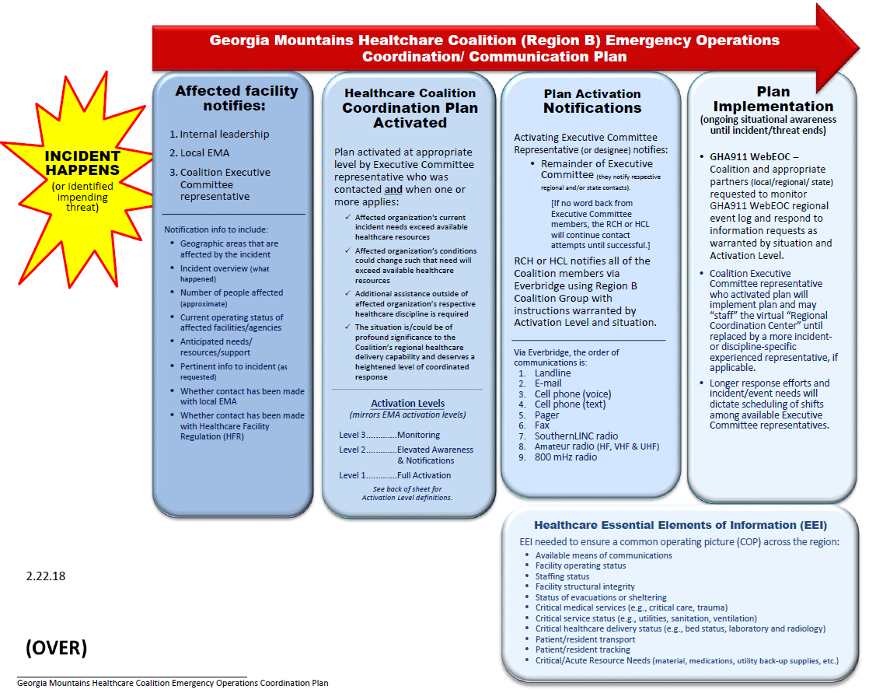
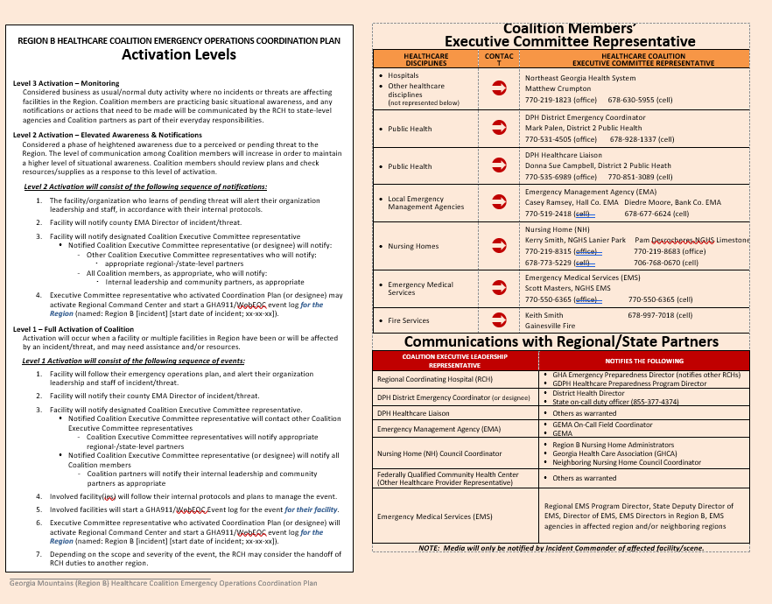

Appendix C: Georgia Mountains Healthcare Coalition Executive Committee Contacts

RCH - Matthew Crumpton
Emergency Preparedness Manager
Coalition Coordinator
Northeast Georgia Health System
(o): 770/219-1823
(c): 678/630-5955
matthew.crumpton@nghs.com

EMA - Casey Ramsey
Hall County EMA
Captain of Special Operations
Department Safety Officer
Hall County Fire Services
(o) 770-503-3215
(c) 770-519-2418
cramsey@hallcounty.org

LTC - Kerry Smith
Executive Director of Long Term Care
New Horizons Lanier Park
(o) 770-219-8315
(c) 678-773-5229
kerry.smith@nghs.com

DPH HCL - Donna Sue Campbell
Emergency Preparedness Healthcare Liaison
Coalition Facilitator
District 2 Public Health
(o) 770-535-6989
(c) 770-851-3089
DonnaSue.Campbell@dph.ga.gov
DPH EC – Mark Palen
District 2 Public Health
(o) 770-531-4505
(c) 678-928-1337
Mark.Palen@dph.ga.gov

LTC-Pamela Desrochers
Manager of Long Term Care
New Horizons Limestone
(o) 770-219-8683
(c) 706-769-0670
Pamela.Desrochers@nghs.com
Hospital – Brian Ensley
Environment of Care Director
Union General Hospital
(c) (706) 400-1151
BrianEnsley@uniongeneral.org

Appendix D: Georgia Mountains Healthcare Coalition Facility Bed Counts

REGION B | FACILITY TYPE |  | # LICENSED BEDS |  |  | CURRENT CENSUS
BANKS
 | TOTAL
BARROW (Region E)
Barrow Regional Medical Center |  | Hospital |  | 56
Winder Health Care & Rehab Center |  | Nursing Home |  | 163
 |  | TOTAL
DAWSON
 | TOTAL
HABERSHAM
Habersham County Medical Center | Hospital |  | 53
Habersham Home | Nursing Home |  | 84
The Oaks Scenic View Skilled Nursing | Nursing Home |  | 148
 | TOTAL
HALL
Willowbrooke Court At Lanier Village Estates | Nursing Home |  | 64
New Horizons Limestone | Nursing Home |  | 134
The Oaks- Limestone | Nursing Home |  | 104
Willowwood Nursing Center | Nursing Home |  | 100
The Bell Minor Home | Nursing Home |  | 104
Northeast Georgia Medical Center | Hospital |  | 557
NGHS Braselton | Hospital |  | 100
New Horizons Lanier Park | Nursing Home |  | 118
 | TOTAL
LUMPKIN
Northeast Georgia Medical Center - Lumpkin | Hospital |  | 49
Chelsey Park Health and Rehabilitation | Nursing Home |  | 60
Gold City Health and Rehab | Nursing Home |  | 102
 | TOTAL
RABUN
Mountain Lakes Medical Center | Hospital |  | 25
Mountain View Health Care | Nursing Home |  | 113
 | TOTAL
STEPHENS
Stephens County Hospital | Hospital |  | 96
Pruitt Health - Toccoa | Nursing Home |  | 181
 | TOTAL
TOWNS
Chatuge Regional Hospital | Hospital |  | 24
Chatuge Regional Nursing Home | Nursing Home |  | 112
 | TOTAL
UNION
Union General Hospital | Hospital |  | 45
Union County Nursing Home | Nursing Home |  | 150
 | TOTAL
WHITE
Friendship Health and Rehab | Nursing Home |  | 89
Gateway Health and Rehab | Nursing Home |  | 60
 | TOTAL

Appendix E: Acronyms

Acronym | Meaning
AAR | After Action Report
ARES | Amateur Radio Emergency Service
CHOA | Children's Healthcare of Atlanta
EEI | Essential Elements of Information
EMA | Emergency Management Agency
EMS | Emergency Medical Services
EOC | Emergency Operations Center
EOP | Emergency Operations Plan
EPD | Environmental Protection Division
EPT | Exercise Planning Team
ESAR-VHP | Emergency System for Advance Registration of Volunteer Health Professionals
ESF | Emergency Support Function
FSE | Full Scale Exercise
GAPHC | Georgia Association for Primary Health Care
GDBHDD | Georgia Department of Behavioral Health and Developmental Disabilities
GDPH | Georgia Department of Public Health
GEMA | Georgia Emergency Management Agency
GHA | Georgia Hospital Association
GHCA | Georgia Health Care Association
HCC | Healthcare Coalition Coordinator
HCF | Healthcare Coalition Facilitator
HICS | Hospital Incident Command System
HSEEP | Homeland Security Exercise Evaluation Program
HVA | Hazard Vulnerability Assessment
HVAC | Heating, Ventilation, and Air Conditioning
ICS | Incident Command System
ISC | Internal Surge Capacity
IT | Information Technology
JIC | Joint Information Center
LE | Law Enforcement
LEPC | Local Emergency Planning Committee
MOU | Memorandum of Understanding
MSEL | Master Scenario Event List
NIMS | National Incident Management System
PAPR | Powered Air Purifying Respirator
PIO | Public Information Officer
PPE | Personal Protective Equipment
RCH | Regional Coordinating Hospital
SERVGA | State Emergency Registry of Volunteers of Georgia
SitMan | Situation Manual
SME | Subject Matter Expert
TTX | Tabletop Exercise

Appendix F: Regional Coordinating Hospital Area Map

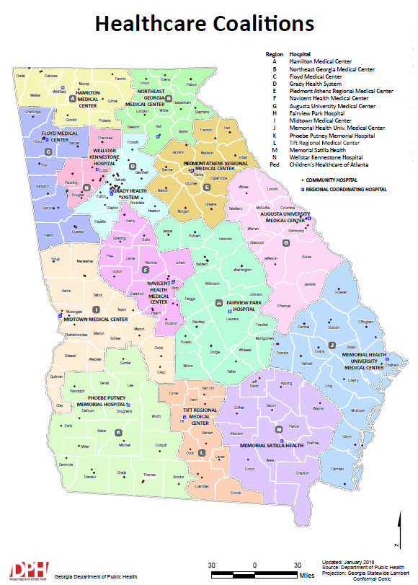

Appendix G: Public Health Districts Map

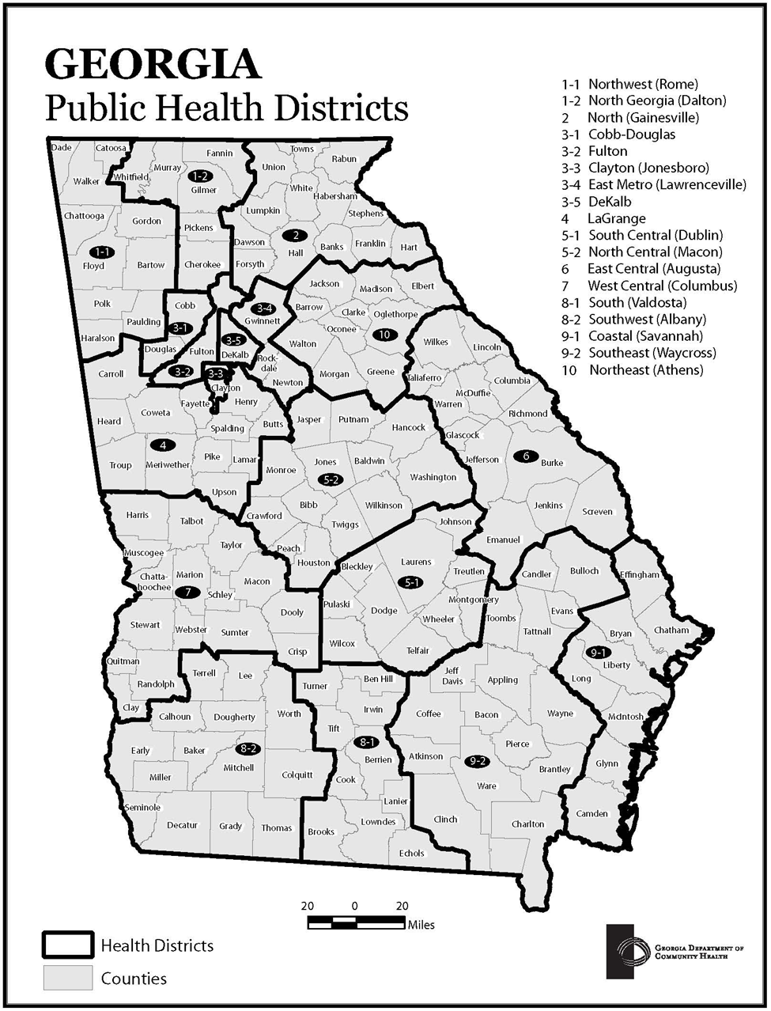

Appendix H: Emergency Medical Service Regions Map

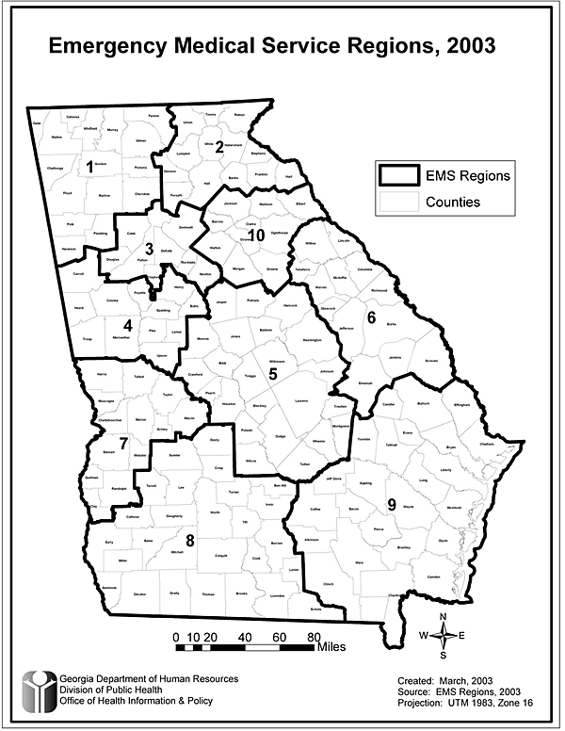

Appendix I: GEMA Regions Map

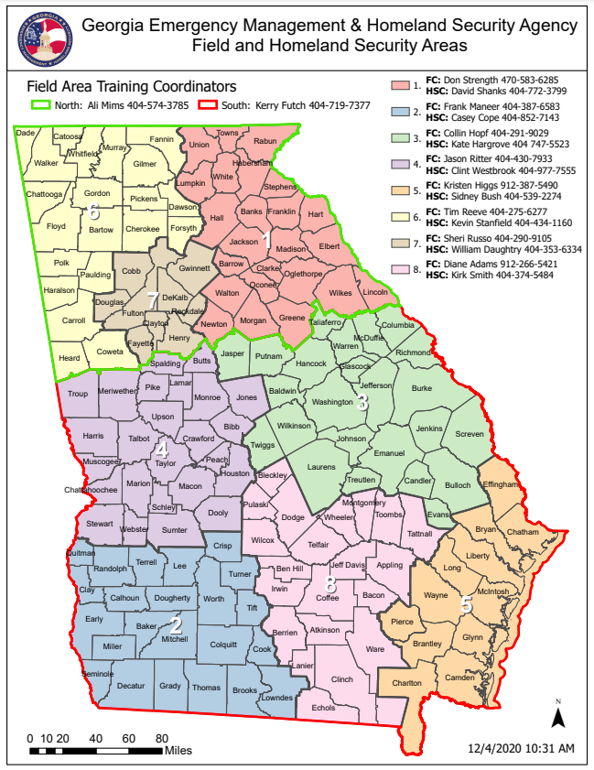

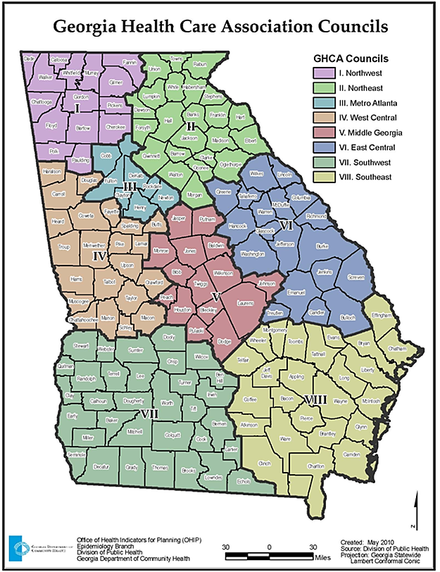
Appendix J: Georgia Health Care Association Council Map
(Nursing Homes)

Appendix K: GAPHC Community Health Centers Map
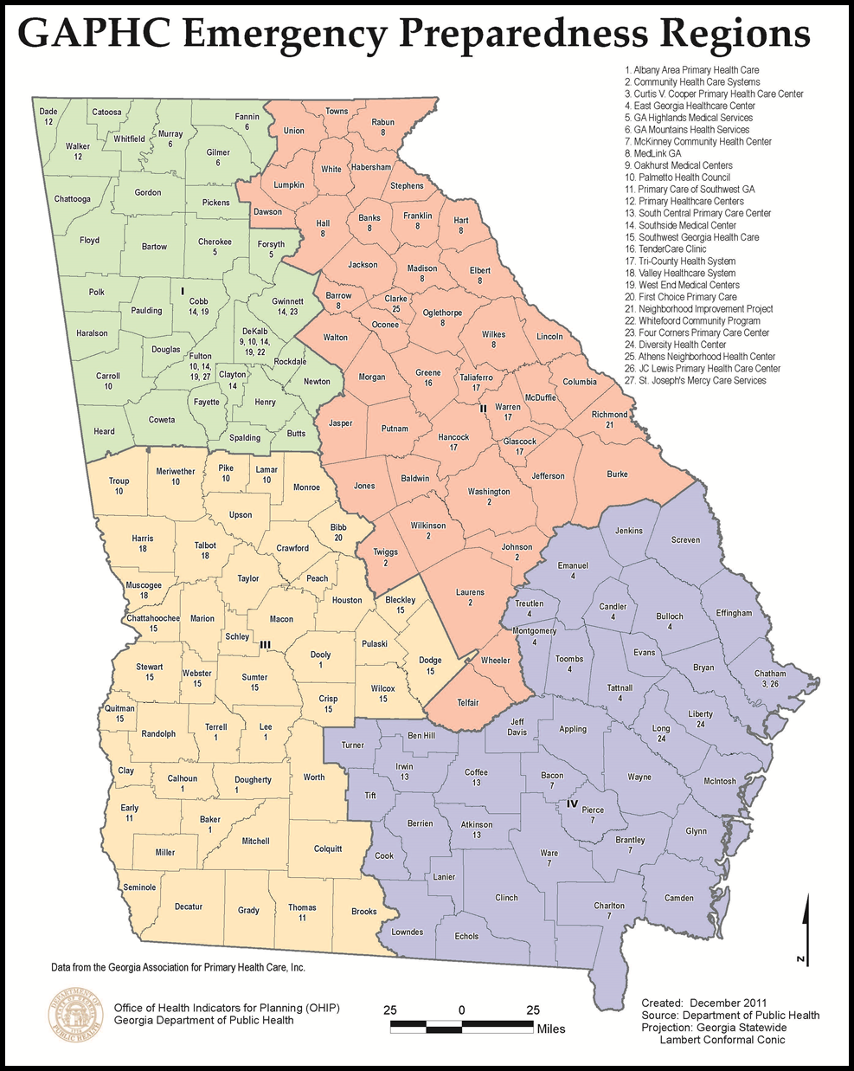

Appendix L: GDBHDD Regional Map

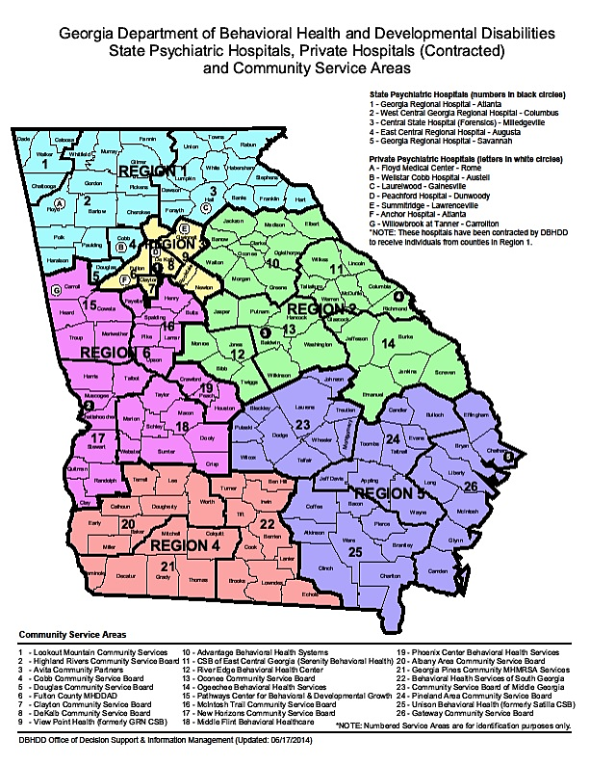

Appendix M: Role of Specialty Coordinating Hospital
Children’s Healthcare of Atlanta (CHOA) has contracted with the Georgia Hospital Association (GHA) to act as the Specialty Coordinating Hospital (SCH) for pediatrics with the state of Georgia. In the event of a disaster, CHOA will assist facilities and regions with pediatric patient needs. CHOA Transfer Center can facilitate the acceptance of pediatric patients.
If the scope of the event exceeds the resources of CHOA, we will work with those facilities within Georgia that have pediatric inpatient capabilities for patient placement. CHOA’s is also a signatory to the Southeastern Regional Pediatric Disaster Network and is in contact with numerous pediatric hospitals across the Southeast (Tennessee, North Carolina, South Carolina, Florida, Kentucky, Alabama, and Mississippi). This organization has a memorandum of understanding to support each other in the event of a disaster involving pediatrics.
For assistance with pediatric patient placement, please call the
Children’s Healthcare of Atlanta Transfer Center
404-785-7778 or 1-888-785-7778

Additional responsibilities of the Specialty Coordinating Hospital (SCH)
Children’s Healthcare of Atlanta will:
- Provide technical assistance for hospitals in the development of plans and exercises as well as during real world emergencies upon request.
- Assistance may include providing additional staffing, sharing expertise and distribution of specialty care supplies and equipment through mutual aid during a disaster or evacuation.
- Participate in regional drills to offer pediatric expertise and to encourage pediatric patients to be included in drill casualties to better prepare for world events
If you need more information on Children’s role as the SCH for pediatrics, please contact Karen Hill at 404-785-6503.
Children’s Healthcare of Atlanta Overview
- CHOA is comprised of three (3) separate hospitals: Egleston, Scottish Rite and Hughes Spalding.
  - Egleston is the only designated Level 1 Pediatric Trauma Center in the state.
  - Scottish Rite is the only designated Level 2 Pediatric Trauma Center in the state.
  - Hughes Spaulding has Pediatric Emergency Department and pediatric general care capabilities.
- Between the 3 campuses, CHOA has over 500 licensed pediatric beds!
- Currently this includes 58 pediatric intensive care beds combined in 2 PICU’s, Neonatal Intensive Care Units (NICU) a Cardiac Intensive Care Unit (CICU) and Technology Dependent Unit (TDICU). Egleston has ECMO capabilities as well.
Additional CHOA Contacts

Trauma intake line for EMS:
404-785-5082 or
State HEAR or
MED Channel 2 or 3

Children’s Transport
404-785-6540 or
1-800-325-6540

- CHOA has all pediatric sub-specialties and will accept pediatric patients in transfer when beds are available.
CHOA can assist with the transport of patients. CHOA can provide ground transportation with up to 7 ambulances and 1 helicopter. CHOA can also assist with fixed wing transport.

Appendix N: GMHC BURN ANNEX

Georgia Mountains Healthcare Coalition (Region B)
Burn Surge Annex

Introduction:
This Burn Annex is in support of the Georgia Mountains Healthcare Coalition (Region B) Healthcare Coalition Response Plan for a Burn Mass Casualty Incident (BMCI) involving large numbers of burn injury.

Purpose:
This annex supports the Georgia Mountains Healthcare Coalition (HCC) response plan in the event of a sudden and unexpected surge in burn care need. A surge can be defined differently based on multiple criteria and other factors such as timing and individual organizations’ operating status. A surge is defined here as “any incident or situation that overwhelms resources” The plan reinforces situational awareness communication to county emergency management, healthcare coalition members, state burn centers, state ESF8, and other state partners. The Georgia Mountains Healthcare Coalition may coordinate and provide logistics support to the incident; however, each facility should refer to their EOP/Surge Plan if applicable.

Goal:
This annex supports the appropriate assessment of the burn surge event, assignment of resources appropriate to the size and severity of the event, and identification of patients that are best served at a burn center. Communication and coordination with the burn centers allows hospitals in the Georgia Mountains Healthcare Coalition to provide care for the critical patients without overwhelming their resources. An additional goal of the annex is to provide support to hospitals holding patients for ultimate transfer to a higher level of burn care as well as in providing care for less critical patients.

Scope:
This annex should not supersede established guidelines; rather support those currently in place.

Annex Structure and Development:
A template was created by a multidisciplinary team of healthcare providers, medical directors, HCC partners and others using current published references and resources already in place. The template was reviewed and modified by the Burn Surge Work Group to guide Georgia Mountains HCC Burn Surge response. This annex relies on the premise that all included partners ascribe to the recommendations already put forth by any established reference or plan covering their local HCC and state.

Healthcare Coalition responsibilities:
To assist in coordination of communication and logistics for critical events

Georgia Mountains Healthcare Coalition Response Plan Process:

Initiation:
Any agency, including but not limited to first responders, emergency management, hospitals, urgent care or health clinics, local health departments, local HCC personnel or other healthcare providers may request activation of this plan.
Communication initiatives should follow accepted protocols and the impacted burn center should participate in notification expansion. Local, state, regional and federal resource procurement should proceed based on the local burn center disaster plan in conjunction with the HCC burn annex and through the transfer and communication platforms established in the Mass Casualty Incident (MCI) response system.

Healthcare Coalition responsibilities:
1| Ensure notification of stakeholders by local hospital(s):
- Internal Leadership, for provision of resources and adherence to appropriate internal plans, policies, and procedures
- Regional Burn Center (per facility plan and/or see Appendix A)
- Local EMA(s) for all affected counties

2| Notify regional and state partners:
- Georgia Coordinating Center, 404-616-6440
- State DPH Duty Officer, 855-377-4374
- Local Health District, 770-851-3089
- Adjoining HCC’s, if additional non specialty beds may be needed
- Coalition Members, as needed for resources
3| Post situational updates and critical elements of information on WebEOC
4| Maintain documentation of resources requests and allocations
5| Assist with communications as needed
6| Assist with implementation of a patient tracking system as needed
7| Assist with coordination between all receiving facilities and specialized burn facilities to account for and manage immediate bed availability as needed
8| Assist with decompression of specialty care and tertiary care facilities increasing bed availability as needed
9| Perform after action review with all appropriate agencies

Assumptions:
The need for expanded burn coverage requires all trauma designated hospitals and appropriate HCC partner members within the coverage area to expect patients during a mass casualty event. Patients will be triaged and stratified based on each facility’s level of expertise with specialty burn hospitals. Trauma/emergency hospitals are expected to take victims with higher levels of acuity and have a greater ability to deal with larger surge numbers while non-trauma facilities manage patients with less acuity.
Initial care of the burn patient is largely focused on resuscitation. Patients with large burns often become unstable after the first 24 hours, however, Trauma Centers should plan to provide supportive care for the first 72 hours.
Patient instability can make transfer more complex so it is imperative those facilities be prepared and have ready access to expert medical resources and seasoned providers.

Communication:
Telemedicine, Apps (see Appendix F), and all other electronic modes of communication should be utilized during BMCI to facilitate effective and standardized triage and care.
As needed, utilize the Georgia Coordinating Center for bed placement after triage.
The Healthcare Coalition should support all communications.

Supplemental Plans:
The American Burn Association Southern Region has developed a Burn Disaster Plan that relies on the cooperation of Burn Centers currently existing within an identified coverage area. In addition, each region also has a similarly developed strategy for large-scale events. The successful implementation of these larger regional plans relies heavily on the mutual aid provided by the individual state plans and each independent Burn Center themselves.

American Burn Association Transfer Criteria:
The American Burn Association (ABA) has listed 10 criteria for burn patients that recommends transfer to a specialized burn treatment facility. Included in that criteria are Hospitals and other facilities that do not have specialty burn teams or facilities that have limited experience/comfort managing burn patients.
(See Appendix D)

Mutual Aid:
Initiation of out of state transfers and coordination of care through the ABA Southern Regional Coordination Center (SRCC) will take place only after all beds and resources are utilized within the state and upon agreement between each burn center director along with the appropriate emergency management, state and disaster coordinators. The Burn Center Director will initiate this.

Record of Review and Changes

Date | Changes/action | Author
Feb 24, 2022 | Template received and sent to Burn Annex Work Group for review and comments | M Crumpton, RCH
Feb 24, 2022 | Added changes/review table and Reg B identification  Several changes and additions made throughout to reflect Reg B response | DS Campbell, HCF
March 2, 2022 | Burn Annex workgroup collaborative comments/edits
March 24, 2022 | Burn Annex workgroup meeting to solidify Region B Final Draft | Frances Franks, RN, Clinical Advisor
March 31, 2022 | Final edits completed | Frances Franks, RN, Clinical Advisor
April 1, 2022 | Georgia Mountains Healthcare Coalition Burn Surge Annex Final Draft submitted to CAT | DS Campbell, HCF

Appendix A: Burn Centers

American Burn Association (ABA) Certified Burn Treatment Centers:
Verified Burn Centers are limited nationally with approximately 133 currently active sites housing about 2000 burn beds. Georgia currently has two ABA verified burn centers and one designated burn center.
Georgia Pediatric and Adult Burn Bed Availability:
HCC Region G:
-JMS Burn Center /BRCA at Doctors Hospital, Augusta: Total Burn Beds: 99
Surge Capacity: 50
Critical Pediatric Ability: Yes
3601 J. Dewey Gray Circle, Augusta, Georgia
Contact phone: 24/7 (706) 863-9595 or (706) 651-3232

HCC Region D:
-Grady Health System at Grady Hospital, Atlanta:
Total Burn Beds: 23
Surge Capacity: 12
Critical Pediatric Ability: Yes
80 Jesse Hill Drive SE, Atlanta Georgia 30303
Contact phone: 24/7 404-616-2090

-JMS / BRCA at Wellstar/Cobb Hospital, Austell:
Total Burn Beds: 16
Surge Capacity: 8
Critical Pediatric Ability: No
3950 Austell Road SW, Austell Georgia 30106
Contact phone: 24/7 (706) 863-9595

Appendix B: Georgia Trauma and Specialty beds

Level 1 * ACS Verified at level specified
*Augusta University Medical Center  1120 15th Street  Augusta, GA 30912  706-721-2273  County: Richmond | *Atrium Navicent Health  777 Hemlock Street  Macon, GA 31201  478-633-1000  County: Bibb
*Grady Memorial Hospital  80 Jesse Hill Junior Drive SW  Atlanta, GA 30303  404-616-2090  County: Fulton | Memorial Health University Medical Center  4700 Waters Avenue  Savannah, GA 31404  912-350-8000  County: Chatham
WellStar Atlanta Medical Center
303 Parkway Drive Northeast
Atlanta, GA 30312
404-265-4000
County: Fulton

Level 2
Atrium Health Floyd  304 Turner McCall Boulevard  Rome, GA 30165  706-509-5000  County: Floyd | *Doctors Hospital of Augusta  3651 Wheeler Road  Augusta, GA 30909  706-651-3232  County: Richmond
Northside Gwinnett Medical Center  1000 Medical Center Boulevard  Lawrenceville, GA 30046  678-312-1000  County: Gwinnett | *Northeast Georgia Medical Center  743 Spring Street Northeast  Gainesville, GA 30501  770-219-9000  County: Hall
Piedmont Athens Regional  1199 Prince Avenue  Athens, GA 30606  706-475-7000  County: Clarke | Piedmont Columbus Regional  710 Center Street  Columbus, GA 31904  706-571-1000  County: Muscogee

Level 3
Advent Health Redmond  501 Redmond Road  Rome, GA 30165  706-291-0291  County: Floyd | Crisp Regional  902 7th Street North  Cordele, GA 31015  229-276-3100  County: Crisp
Fairview Park Hospital  200 Industrial Boulevard  Dublin, GA 31021  478-275-2000  County: Laurens | Hamilton Medical Center  1200 Memorial Drive  Dalton, GA 30720  706-272-6000  County: Whitfield
John D. Archbold Memorial Hospital  915 Gordon Avenue  Thomasville, GA 31792  229-228-2000  County: Thomas | Piedmont Cartersville  960 Joe Frank Harris Parkway SE  Cartersville, GA 30120  470-490-1000  County: Bartow
Piedmont Walton  2151 West Spring Street  Monroe, GA 30655  770-267-8461  County: Walton | WellStar Cobb Hospital  3950 Austell Road SW  Austell, GA 30106  470-732-4000  County: Cobb

Level 4
Effingham Health System  459 Highway 119 South  Springfield, GA 31329  912-754-6451  County: Effingham | Emanuel Medical Center  117 Kite Road  Swainsboro, GA 30401  478-289-1100  County: Emanuel
Memorial Health Meadows Hospital  1 Meadows Parkway  Vidalia, GA 30474  912-535-5555  County: Toombs | Morgan Medical Center  1740 Lions Club Road  Madison, GA 30650  706-752-2261  County: Morgan
Polk Medical Center  2360 Rockmart Highway  Cedartown, GA 30125  770-748-2500  County: Polk | Winn Army Community Hospital  1061 Harmon Avenue  Fort Stewart, GA 31314  912-435-6633  County: Liberty

Specialty Hospitals – Children

Atrium Health Navicent Beverly Knight Olsen Children's Hospital
888 Pine St,
Macon, GA 31201
478-633-1000
County: Bibb

*Children's Healthcare of Atlanta @ Egleston (Level I)
1405 Clifton Road Northeast
Atlanta, GA 30322
404-785-7778
County: DeKalb

Children’s Healthcare of Atlanta @ Hughes Spalding
35 Jesse Hill Jr Dr SE
Atlanta, GA 30303
404-785-7778
County: Fulton

Children's Healthcare of Atlanta @ Scottish Rite (Level II)
1001 Johnson Ferry Road
Atlanta, GA 30342
404-785-7778
County: Fulton

*Children's Hospital of GA @ Augusta University (Level II)
1446 Harper Street
Augusta, GA 30912
706-721-5437
County: Richmond

Memorial Health Dwaine & Cynthia Willett Children Hospital
4700 Waters Ave,
Savannah, GA 31404
912-350-8000
County: Chatham

Appendix C: Definitions and Acronyms

Ancillary Facilities: Healthcare providers, other than hospitals and specialty hospitals.
ABA- American Burn Association
Burn Disaster: a massive influx of patients that exceeds a burn centers capacity and capability
BMCI: Burn Mass Casualty Incident
Burn Surge: Burn patient volumes challenge or exceed a hospital servicing capacity
Critical Event: Emergency or Disaster requiring resources outside the abilities of the local community
Disaster: Requires more resources than readily available in the local response area
EOC: Emergency Operations Center
GCC: Georgia Coordination Center
GMHC: Georgia Mountains Healthcare Coalition
JMS/BRCA/Doctors: Joseph M. Still Burn Center/Burn and Reconstructive Centers of America at Doctors Hospital, Augusta
JMS/BRCA/Wellstar: Joseph M. Still Burn Center/Burn and Reconstructive Centers of America at Wellstar Cobb Hospital, Austell
MCI: Mass Casualty Incident
Specialty Hospitals: A hospital that provides a limited range of services (e.g., burn, orthopedic surgery, obstetrics or pediatrics)
SRCC: Southern Regional Coordination Center
TBSA: Total Body Surface Area of Burn

Appendix D: American Burn Associations Transfer Criteria

The American Burn Association and the American College of Surgeons recommend transfer to a burn center for all acutely burned patients who meet any of the following criteria (Questions concerning specific patients should be resolved by consultation with the burn center physician):

- Partial thickness burns >= 20% Total Body Surface Area (TBSA) in patients aged 10 - 50 years old.
- Partial thickness burns >=10% TBSA in children under age 10 or adults over age 50 years old.
- Full-thickness burns >= 5% TBSA in patients of any age.
- Patients with partial or full-thickness burns of the hands, feet, face, eyes, ears, perineum, and/or major joints.
- Patients with high-voltage electrical injuries, including lightning injuries.
- Patients with significant burns from caustic chemicals.
- Patients with burns complicated by multiple trauma in which the burn injury poses the greatest risk of morbidity or mortality. In such cases, if the trauma poses the greater immediate risk, the patient may be treated initially in a trauma center until stable before being transferred to a burn center. Physician judgment will be necessary in such situations and should be in concert with the regional medical control plan and triage protocols.
- Patients with burns who suffer inhalation injury.
- Patients with significant ongoing medical disorders that could complicate management, prolong recovery, or affect mortality.
- Hospitals without qualified personnel or equipment for the care of children should transfer children with burns to a burn center with these capabilities.
- Burn Injury in patients who will require special social/emotional and /or long-term rehabilitative support, including cases involving suspected child abuse, substance abuse, etc.

Appendix E: Southern Region 1 Coordination Center Algorithm (SRCC)
To request assistance the affected Burn Director can contact the SRCC at University of Alabama, 800-359-0123
{Note: the Burn Center Medical Director or their designee activates this system}
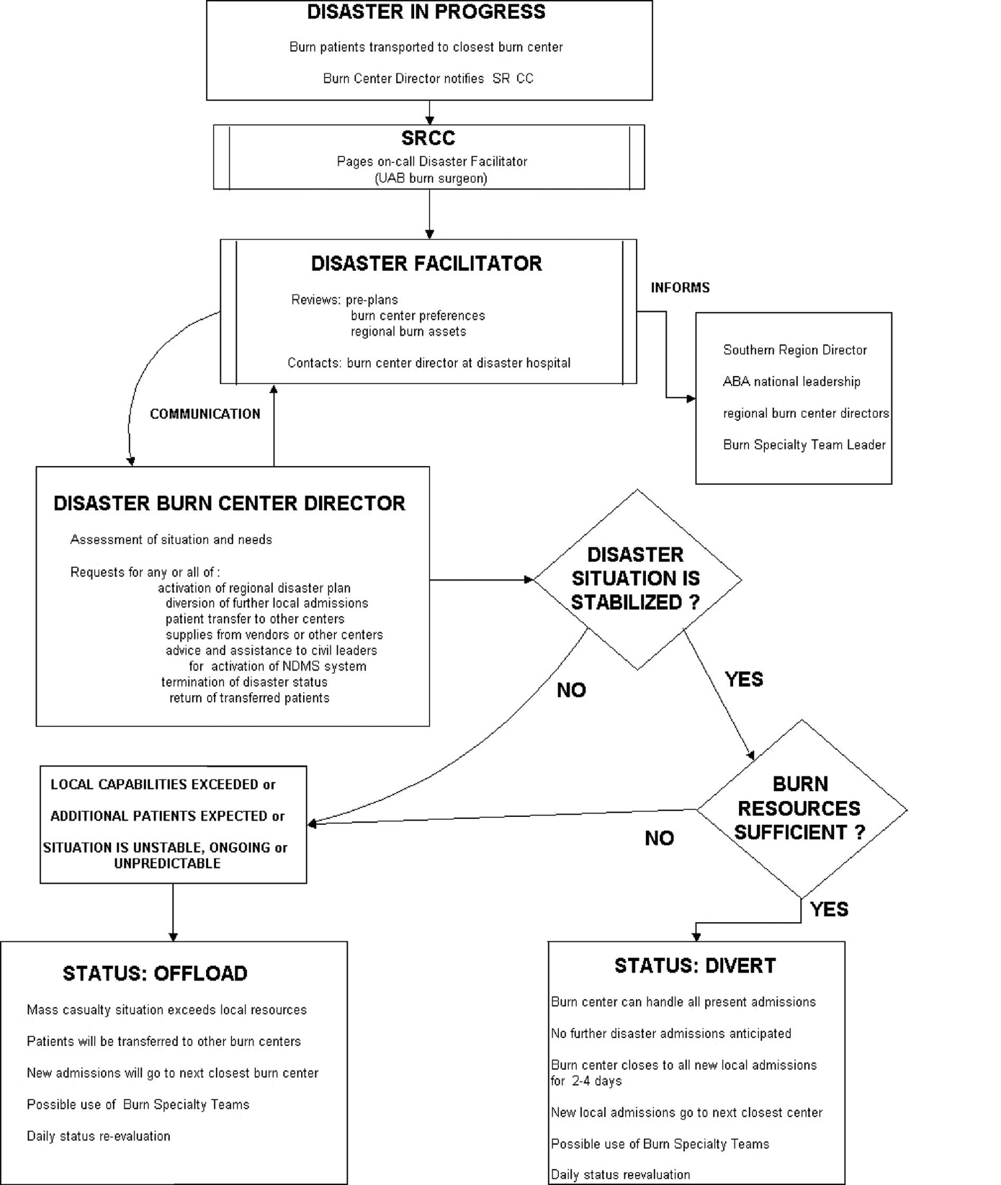

Appendix F: Joseph M. Still Burn Centers/BRCA mobile APP

In addition, the Joseph M. Still Burn Centers/BRCA has available a mobile APP that allows practitioners in non-burn specific care centers the ability to quickly upload photos and communicate with burn specialists on a secure encrypted platform.
( https://burncenters.com/app/ )

