Georgia Mountains Healthcare Coalition (Region B) Quarterly Meeting Agenda
February 20th 10:00 AM – 1:00 PM
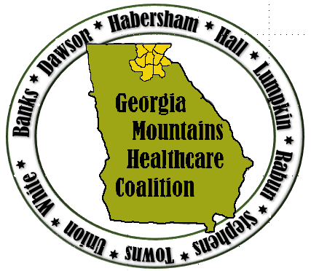
Auxiliary Conference Room
Northeast Georgia Medical Center, Gainesville GA
- Opening Remarks and Introductions
- Coalition information/updates
  - Region B website
- Training Updates
  - TECC, BDLS, TEPW
- Exercises
  - Active Shooter Table Top Exercise (TTX) March 14
  - Situational Manual (SitMan)
- Workgroup for Response Plan
- Stop the Bleed, Chad Black
- PH, GHA and State Updates
- Hospital, EMA, LTC, Behavioral Health, ARC, other partner updates
- Open Forum
Future Region B Coalition Meeting Dates:
May 22nd – NGMC Gainesville Auxiliary Conference Room
August 21st – NGMC Braselton – Education Conference Room
November 20th - location to be determined. Hosts welcome!
MATF (Mutual Aid Task Force) Meetings: March 22 (Fri), September 13 (Fri), Dec 12 (Th)
Location: Georgia Public Safety Training Center Bay A; 1000 Indian Springs Drive Forsyth, GA
- Other happenings:
- Feb 28 -Training and Exercise Planning Workshop, GPSTC, Forsyth
- March 4-6 Tactical Emergency Casualty Care (TECC) course, Hall Co. Sheriff’s Training Center, Gainesville
- March 14-Georgia Mountains (Region B) Tabletop Exercise, Gainesville Civic Center
- April 17-19 Emergency Management Summit and Training, Savannah

Matthew Crumpton, NRP, MEP, CEM-GA, EMHP Donna Sue Campbell
Emergency Preparedness Manager Emergency Preparedness Healthcare Liaison
Northeast Georgia Health System District 2 Public Health
743 Spring Street 1280 Athens St.
Gainesville, GA 30501 Gainesville, GA 30507
(O): 770/219-1823 (p) 770-535-6989
(C): 678/630-5955 (f)770-535-5958
matthew.crumpton@nghs.com DonnaSue.Campbell@dph.ga.gov

