Meeting Minutes – Region B Unified Healthcare Coalition
Nov 14, 2018

Clermont Chattahoochee Center, 639 Main Street, Clermont, GA

Attendees: Please see sign in sheet posted to GHA 911 for this meeting

Convened: 10:00 Adjourned: 1:20

TOPIC | DISCUSSION | FOLLOW-UP
Welcome and Introductions | All participant introduced themselves | Exchange contact info with others
Coalition Information/Updates  Matthew Crumpton, HCC | 2018-2019 Budget  Complete budget is posted to GHA911.org  Highlights below:  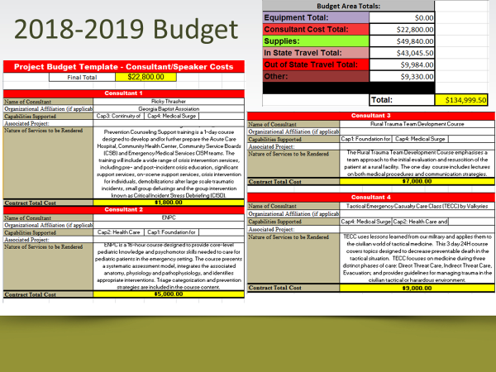  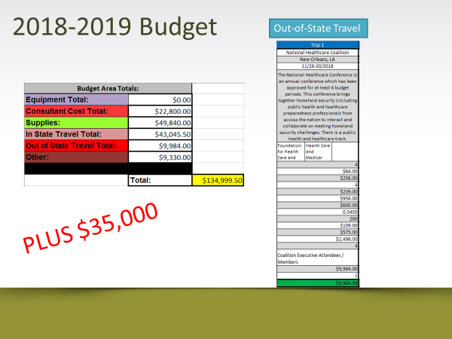  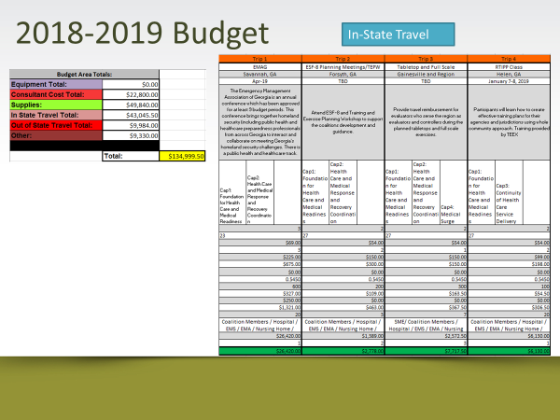  - Ebola coalition funds - $180,000  - Must be spent before 6/30/2020  - Must be spent on items for infection control  - Survey monkey went out in email several months ago, we’ll send it out again.  - Please give details as to what you want to purchase including item name, number, company, price,
Full Scale Exercise (FSE)  After Action Report | Full Scale Exercise: August 29  Severe Weather with Storm Victims/School Bus Wreck  Many agencies, participants, and facilities participating  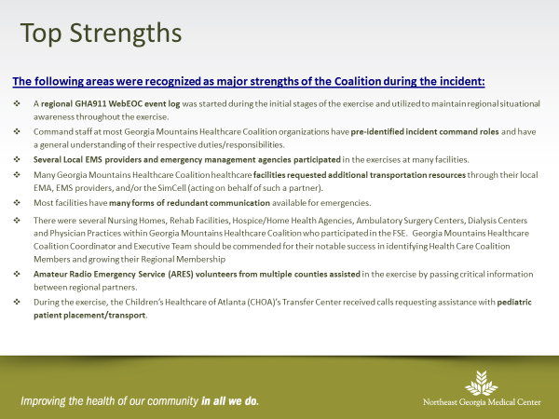  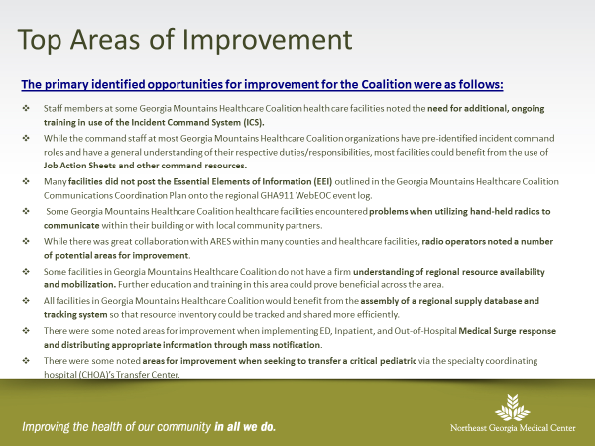 | AAR is available on sign up table and also on GHA911.org  There were 108 Healthcare Organizations and Community Partners that participated.  Thanks to all participants and evaluators!  Think of future exercises and training needs to meet this improvement plan
Training Updates | Readiness:  Training Identification and Preparedness Planning MGT-418  January 7-8 at Unicoi State Park and Lodge  - Rooms available Jan 6-7 for GMHC members at Unicoi State Park Lodge for first 10 who register, others needing rooms will be reimbursed as needed  - Go back to your community and invite your planning and response partners such as EMA, EMA, Utility Companies, Police, and others  Long Term Care Emergency Preparedness Class  Jan 15, 2019 at Gainesville Civic Center  You can go to any of the trainings throughout the state if you can’t attend the one in our District | Flyer available on sign in table or register at  https://tinyurl.com/yc8jvkje  https://tinyurl.com/LTCEP2018B
Partner Updates  Adriane Feinberg,  Georgia Hospital Association  Alexandra Benoit,  Vulnerable Populations Coordinator, GDPH | Stop the Bleed kits have been purchased through the Trauma Commission for EDs  Ebola outbreak in DRC  - Continue to ask travel questions of all patients  - Implement appropriate Isolation and Quarantine measures if symptoms and travel history indicate  - If you need further recommendations, contact  1-866-PUB HLTH  Human trafficking response and awareness  Resources for info and tip line  - Dignity Health  - Blue Campaign (Homeland Security)  GHA911 – continue to update your info, especially when staff change or email changes  NH, Hosp – continue to update bed counts every Wed  Personal Care Homes and Assisted Living Facilities have new EP requirements under the DCH New Disaster Preparedness Rule.  - They must initiate and maintain an account on GHA911  - Must contact their local EMA and provide evidence  - Attend a minimum of one Coalition meeting annually  GDPH, GEMA, and GHCA are working together to gather info on power and generators in Skilled Nursing Facilities.  - There will be a “Power/Utility Survey” sent out soon  - Please complete this survey, there may be grant funding at some point for generators or transfer switches | For situational awareness  Remember to ask travel questions to clients and patients  Be prepared to  - Identify  - Isolate  - Inform – call 866-PUB HLTH  https://www.dignityhealth.org/hello-humankindness/human-trafficking  https://www.dhs.gov/blue-campaign  - Please keep contact info up to date in Everbridge, especially with staff changes  - Please update bed counts every Wednesday and other times when requested  - WebEOC platform changing, “go live” date is Nov 20  Skilled Nursing Facilities - Please complete the “Power/Utility Survey” when you get it
Mark Palen,  District 2 Public Health  Tamika Bowden,  MRC, Volunteer Program  GDPH | Many Fall Flu Clinics scheduled, get your flu shot!  Public Health participated in six drive thru flu clinics in District, open and closed PODS.  This serves as way to practice mass dispensing and serve vulnerable populations who have difficulty getting out of vehicle  - Reminder that Medical Reserve Corp needs non medical volunteers, also  - First Servega conference will be April 2019  - Contact Lakieva Williams or Tamika for details | If you have a clinic, Public Health is available to assist in messaging or staffing clinics  Register at https://ServGa.gov  If you would like to volunteer
Open Forum | Discussion on what to buy with funds  - Several facilities (HCMC and SCH) would like to participate in Trauma Nurse Casualty Care Course as they have trained instructors  - Website development for Coalition  Ideas for Ebola Grant such as PPE  - Please submit all details such as manufacturer, item number, cost when you send in requests.  - Survey will be sent out again for you to fill out with your PPE or other infectious disease response requests  - Environmental services cleaning equipment or supplies  - Some examples of equipment  - TR600 Respirators  - DCON tent  - PAPR  - Education and Training | Please complete survey to let us the info on what infectious disease response items you need
Tools/Handouts | - Full Scale Exercise Aug 29, 2018 After Action Report  - Coalition contact information sheet  - Flyer on LTC Emergency Preparedness Training, January 15, 2019 at Gainesville Civic Center  - Flyer on RTIPP (see below)
Future Meetings and Trainings | - Mutual Aid Task Force, Dec 7, GPSTC  - National Healthcare Coalition Conference, Hilton Riverside Hotel, New Orleans Nov 27-29  - RTIPP- Readiness: Training Identification and Preparedness Planning, Helen, GA Jan 7-8, 2019  Class is gap assessment, they tell us what trainings we need (overnight travel funding available)  - Long Term Care Emergency Preparedness Basic Course Jan 15, 2019 at Gainesville Civic Center  - Georgia Mountains Healthcare Coalition Meeting:  - February 20th – NGMC Gainesville Auxiliary Conference Room  - May 22nd- NGMC Gainesville Auxiliary Conference Room  - August 21st- NGMC Braselton – Education Conference Room  - Public Health Summit, St. Louis, MO, March 26-29, 2019  - Emergency Management Training and Summit, Savannah, April 17-19, 201 | Please let us know what you want for training.  These trainings are scheduled based on feedback from Region B Healthcare coalition members.  There are very few Region B Coalition members in some of these trainings and we want to make sure we offer trainings that members want to attend.
Summary of Tasks | - Please complete Power/Utility Survey when received  - Please complete infectious Disease request for Ebola Grant when received  - Talk to community partners and discuss who should participate in Readiness: Training Identification and Preparedness Planning (MGT-418) and register for course  - Register for Long Term Care Emergency Preparedness Course Jan 15, 2019
Adjourn | Thank you for attending | Please take this information back to your coworkers and executives

