Georgia Mountains (Region B) Healthcare Coalition
Meeting Minutes
May 24, 2022

Lanier Technical College, Gainesville, GA
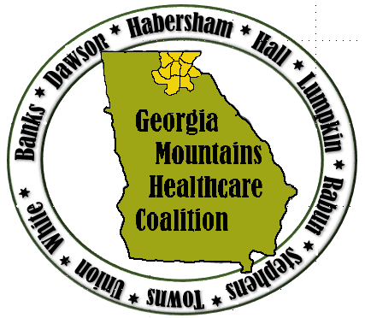

Attendees: Please see sign in sheet attachment, also posted to GHA 911and www.garegionb.org for this meeting
This meeting and TTX also had a virtual option

Start: 9:00 AM Adjourned: 1:00 PM

Welcome and Introductions
- All members introduced themselves

Burn Education video
- Overview of Burn Response
  - Morgan Taylor, MPH, AEMT
    - University of Georgia Institute for Disaster Management

Active Threat Tabletop Exercise
- Scenario: Active Shooter and Burn Surge
  - Small table groups and virtual discussions with facilitator using Situation Manual as guide
- Hot Wash

Burn Surge Annex
- Burn Surge Annex was referenced during TTX.
- Annex was approved developed my the Burn Surge Annex Workgroup and approved at this meeting. .
- Thank you to Frances Franks, Clinical Advisor, for her leadership on the annex.
  - Other members who participated in the workgroup are as follows:
    - Matthew Crumpton
    - Donna Sue Campbell
    - Mallory Danner
    - Pam Knepp
    - Walker Schlunt

Partner Sharing:
Adrianne Feinberg, Georgia Hospital Association
- Patient tracking devices are no longer used but can be recycled
  - Please return them to GHA staff or coalition leadership
- WebEOC Transition- WebEOC is now on the DPH platform
  - Continue to access WebEOC through GHA911.org
  - Each facility registered has one username and password
  - Please sign in and become familiar with the new format
  - Training is available GHA911.org and Everbridge training in the gallery & video’s folder on GHA911.org

Volunteer Program Overview
LaKieva Williams (info in chat)
- SERVGA.gov
- Website to register volunteers, allows for organization and pre-credentialing before a disaster or event occurs
- Update your unit and have your volunteers update their info
- Volunteers can now upload COVID vaccination card
- train.org/mrc
- has helpful resources and cover a variety of topics.
- Contact Lakieva if you have questions LaKieva.Williams@dph.ga.gov need volunteers for exercises or real-world responses
Future Meetings and Trainings
- Healthcare Coalition Meetings
  - August 17, 2022, Location to be determined

Reminders:
- Register for trainings on Training Registration System (TRS) if you’re interested and let us know what trainings you would like
- Please take information from meeting back and share with your executive team

