Georgia Mountains (Region B) Healthcare Coalition
Quarterly Meeting via Conference Call
Minutes
May 19, 2021
10:00-11:45 AM

Participants: Please see list of participants posted to GHA 911.org and www.garegionb.org
Convened: 10:00 AM Adjourned: 11:45 AM

Opening
Coalition Info/Updates:
Matthew Crumpton, NGHS, Emergency Preparedness Manager
- TECC in White County this month and all other scheduled training now completed
- Matthew is teaching in-person DCON classes including a Train the Trainer course Sept 15-17 at NGHS Braselton
- Other trainings are listed in minutes below.
- Look for emails and check the TRS (Training Registration System) soon as they will be posted when finalized

Exercise Updates
Tabletop Exercise April 7, 2021 via WebEx – Severe /Weather
- Reviewed After Action Report and Improvement Plan
- Posted on GHA911 and Region B website

Functional Exercise: Mass Casualty Event during Severe Weather
August 25, 2021
- Still in planning stages

Multi-Year Training and Exercise Plan
- Trainings scheduled (as budget and schedule allows)
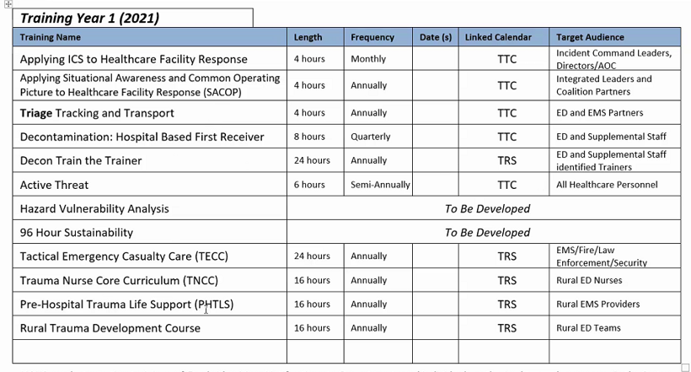

Budget 2021-2022
Reviewed and approved

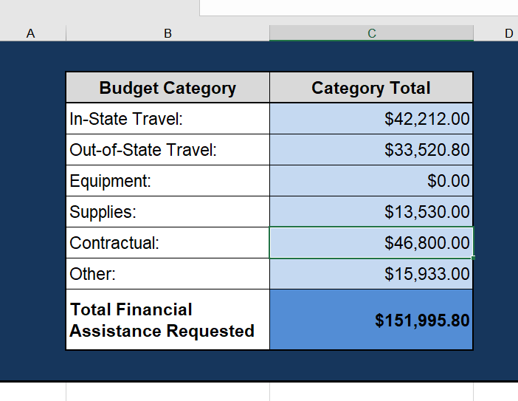

- Instate Travel includes meetings, EMAG conference
- Out of State Travel includes National Healthcare Coalition Conference, North Carolina Coalition meetings
- Supplies include Stop the Bleed kits, Bioesque, respirators
- Contractual includes website, Infectious Disease Conference and training (see above)
- Other includes in person Coalition Meetings, Tabletop Exercise, and assorted travel expenses

Infectious Disease Plan Annex
- Plan was developed and becomes an annex to the Coalition Response Plans
- Plan was reviewed and accepted by Executive Committee in April
- Sent to Coalition members for review and comments
- Thank you to all who provided input and feedback on the plan!
- As there were no other comments voiced today, plan is approved and adopted

Community Partner Updates
Frank Daniell, Training and Exercise Coordinator, GDPH
- State will soon have module to host trainings via TRS which will include on line self-paced training

Lakieva Williams, Georgia Department of Public Health, Volunteer Program Director
- There has been an increase of volunteers over the past year
- Servga.gov ( https://www.servga.gov/ ) is the volunteer management system and available for use.
- Contact her for more info
  - LaKieva.Williams@dph.ga.gov phone: 404-736-8163

Hannah Byers, Emergency Preparedness Coordinator, Georgia Health Care Association
- Long Term Care Appendix D is available
- Has information in it about increased documentation and training, information on infectious disease
- Governor’s Executive Order and Public Health information on vaccination and visitation
- Please remember daily reporting

Adrienne Feinberg, Georgia Hospital Association
- Hospitals with ED’s were sent a survey to gather data on Pediatric Readiness, please complete this

Mallory Garrett, Georgia Hospital Association, Emergency Preparedness Communications Manager
- Training for GHA911 and Everbridge is on Tuesdays, please see GHA911 website under “calendar of events” for dates an registration links
- WebEOC training will be added soon
- If you have questions, please contact her
  - Mallory Garrett mgarrett@gha.org 770-249-4532

Jeannette David, Georgia Department of Public Health, Disaster Mental Health
Some resources for mental health during COVID19 and all other times
- Georgia COVID-19 Emotional Support Line 866-399-8938
- Georgia Crisis and Access Line 800-715-4225
- Her contact information:
  - Jeannette David, jeannette.david@dbhdd.ga.gov, 678-616-7972

Donna Sue Campbell, Public Health, District 2
- DPH COVID19 testing at Hall County Soccer Fields continues with MAKO Medical Information and link to registration is on District 2 PH website http://phdistrict2.org/
- Some Health Departments have moved vaccination from off site to back at Health Departments due to decreasing numbers
- Appointments encouraged but walk ups are welcome
  - Check website for appointments and locations

Matthew Crumpton, NGHS
- Have 38 patients with COVID at present
- Barrow campus is in process of DVM review

Deidre Moore, Banks Co. EMA
- EMAG has a meeting every month, next one is in Elbert County and all are welcome to participate

Brian Ensley, Union County Hospital
- Looking forward to DCON training tomorrow

Updates from chat and emails:
Introduction - Ashlie Pullen, Georgia Department of Public Health, Deputy Chief Nurse Emergency Preparedness
  - Contact information: ashlie.pullen1@dph.ga.gov

Catherine Murphy, AVITA Community Partners, Health, Safety, and Client Rights Officer
- Our Behavioral Health Crisis Center is in the licensing process now and we are hopeful to transition our current Crisis Stabilization Unit over to the new facility in July this summer.
- There will be 30 Crisis Stabilization Beds
- Click on this link to see an article about the BHCC posted by accessWDUN: https://accesswdun.com/article/2021/5/1006464/avita-to-open-behavioral-health-crisis-center

Kristopher S. Mattson, Emergency Preparedness Manager, Children’s Healthcare of Atlanta
- Children’s Pediatric Drive In testing site is closing May 21st
- Children’s Pediatric Vaccine site at the Georgia International Convention Center is closing June 19th
  - We are seeing very little turn out , possibly with local vaccine availability throughout the state
- Also, I am working with Normal Campbell on the distribution of Quantum EMS Pediatric Restraint systems to each of the regions. We utilized some carry over funding to purchase a number of units and will work with the state on an equitable distribution process.
- Very interested in the Decon Train the Trainer program as I am still in need of that capability, so any additional details on when that will be posted would be wonderful.

Closing:
- Thank you to everyone for participating, maybe we can have in-person option for next meeting, too
- Take care of yourself!

Next meetings/WebEx:
- Aug 18, 2021
- Nov 17, 2021

