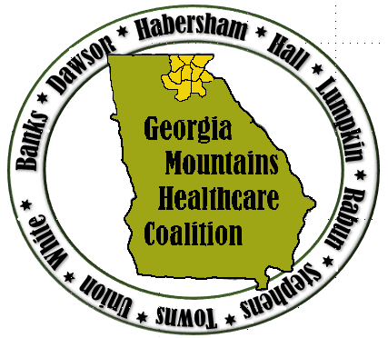
Severe Weather Regional Tabletop Exercise
This discussion-based exercise focuses on Region B healthcare facilities’ and community partners’ ability to respond to a regional severe weather event. This will include reviewing local and regional response plans, as well as, engaging in discussion to address potential gaps that may exist.
This is a virtual exercise with all healthcare facilities participating from various locations.

Who: Georgia Mountains Healthcare Coalition (Region B)
When: Wednesday April 7, 2021 10:00 am – 12:00 pm
Where: Virtual through WebEx

Severe Weather Exercise Objectives:
- Review regional and internal plans, policies, and procedures of Region B healthcare facilities and community partners needed to respond to a regional severe weather event;
- Review communications plans involving incident notification and ongoing situational awareness among area healthcare facilities, local governments, and regional partners;
- Review internal surge plans; and,
- Review procedures for establishing command and control operations.
Use the link below to register:

https://www.surveymonkey.com/r/4721ttx

Exercise Guidelines
- This is an open, low-stress, no-fault environment. Varying viewpoints, even disagreements, are expected.
- Respond based on your knowledge of current plans and capabilities (using only existing assets) and insights derived from training.
- Decisions are not precedent-setting and may not reflect your organization’s final position on a given issue. This is an opportunity to discuss and present multiple options and possible solutions.
- Issue identification is not as valuable as suggestions and recommended actions that could improve response and preparedness efforts. Problem-solving efforts should be the focus.
- Healthcare facilities should use the exercise day's actual patient/resident census to the tabletop exercise for use during discussions.

