Georgia Mountains Healthcare Coalition
Severe Weather Virtual Tabletop Exercise
April 7, 2021

After Action Report
Improvement plan
Published: April 13, 2021

Note: This After Action Report (with included Improvement Plan Appendix) aligns selected exercise objectives with preparedness doctrine to include the National Preparedness Goal and related frameworks and guidance.

Findings in this report are based upon observations of exercise facilitators and evaluators in addition to feedback provided by exercise participants.

Contents
Handling Instructions 4
Exercise Overview 5
Exercise Planning and Participation 6
Exercise Planning Team (EPT) 6
Participating Organizations 6
Number of Attendees 6
Tabletop Exercise Planning and Preparation 7
Executive Summary 8
Analysis of Core Capabilities 9
Summary of Core Capability Performance 9
Analysis of Exercise Objectives 10
Appendix A: Improvement Plan Worksheet 17
Appendix B: Georgia Mountains Healthcare Coalition Healthcare Facility Bed Counts 19
Appendix C: Georgia Mountains Healthcare Coalition Communications Coordination Plan 20
Appendix D: WebEOC Event Log – TTX 22
Appendix E: EverBridge Messages 25
Appendix F: Acronyms 27
Appendix G: Regional Coordinating Hospital Area Map 28
Appendix H: Public Health Districts Map 29
Appendix I: Emergency Medical Service Regions Map 30
Appendix J: GEMA Regions Map 31
Appendix K: Georgia Health Care Association Council Map 32
Appendix L: GAPHC Community Health Centers Map 33
Appendix M: GDBHDD Regional Map 34
Appendix N: Georgia ARES Districts 35
Appendix O: Government Emergency Telecommunications Service (GETS) Fact Sheet 36
Appendix P: Wireless Priority Service (WPS) Fact Sheet 38
Appendix Q: Role of Specialty Coordinating Hospital 40

Handling Instructions
The title of this document is Georgia Mountains Healthcare Coalition Severe Weather Virtual Tabletop Exercise (TTX) After Action Report (AAR).
The information gathered in this AAR is For Official Use Only and should be handled as sensitive information not to be disclosed. This document should be safeguarded, handled, transmitted, and stored in accordance with appropriate security directives. Reproduction of this document, in whole or in part, without prior approval from the Georgia Mountains Healthcare Coalition EPT, or the Georgia Mountains Healthcare Coalition Regional Coordinating Hospital, Northeast Georgia Health System, is prohibited.
For more information, please consult the following points of contact:
Name | Phone | Email
Georgia Mountains Healthcare Coalition RCH Northeast Georgia Health System
Matthew Crumpton, NRP, MEP, CEM-GA, EMHP  Emergency Preparedness Manager  Georgia Mountains Healthcare Coalition Coordinator | Mobile: 678.630.5955  Office: 770.219.1823 | matthew.crumpton@nghs.com

Exercise Overview
Exercise Name | Georgia Mountains Healthcare Coalition Severe Weather Virtual Tabletop Exercise
Exercise Date | April 7, 2021
Scope | Prior to initiation of the WebEx tabletop, all NGHS facilities functionally tested their respective weather checklists and took actions to identify gaps with overhead paging and EverBridge messages. This discussion-based exercise focuses on Georgia Mountains Healthcare Coalition healthcare facilities’ and community partners’ ability to respond to a regional severe weather event. This will include reviewing local and regional response plans, as well as engaging in discussion to address potential gaps that may exist.
Mission Areas | Prevention, Protection, Mitigation, and Response
Core Capabilities | Emergency Operations Coordination, Information Sharing, and Medical Surge
Objectives | Emergency Operations Coordination  - Capability Target 1: Assess and notify stakeholders of healthcare delivery status.  - Capability Target 2: Support healthcare response efforts through coordination of resources.  Information Sharing  - Capability Target 1: Provide healthcare situational awareness that contributes to the incident common operating picture.  - Capability Target 2: Develop, refine, and sustain redundant, interoperable communication systems.  Medical Surge  - Capability Target 1: Coordinate the healthcare organization response during incidents that require medical surge.  - Capability Target 2: Coordinate integrated healthcare surge operations with pre-hospital Emergency Medical Services (EMS) operations.
Threat or Hazard | Severe Weather (Tornadoes)
Scenario | The National Weather Service has been monitoring a severe weather system that has been impacting much of the Southeastern United States over the past two days. This fast-moving storm is now entering Georgia and expected to sweep eastward, greatly impacting the Northeast Georgia region and surrounding counties. It is expected that Georgia Mountains Healthcare Coalition healthcare facilities and community responders will have to share information and coordinate a medical surge/mass casualty response as a result of storm damage.
Sponsors | Georgia Mountains Healthcare Coalition, Northeast Georgia Health System Regional Coordinating Hospital
Participating Organizations | 73 Participating Healthcare Organizations and Community Partners (see page 5 for complete listing)

Exercise Planning and Participation

Exercise Planning Team (EPT)
Representatives of the following organizations participated in the Georgia Mountains Healthcare Coalition Tabletop Exercise planning process by attending scheduled regional exercise planning meetings:

- District 2 Public Health
- Northeast Georgia Health System

Participating Organizations
The following organizations were represented at the Georgia Mountains Healthcare Coalition Tabletop Exercise:

- Affinis Hospice – Gainesville
- ALG Senior
- Amber Glen Personal Care Home
- Amedisys Home Health
- American Red Cross Northeast Georgia
- Avita Community Partners
- Banks County Coroner
- Banks County EMA / E-911
- Banks County Fire/EMS
- Brown Health and Rehab
- Chatuge Interventional Pain Solution
- Chatuge Regional Hospital
- Chatuge Regional Nursing Home
- Chelsey Park Health and Rehabilitation
- Clearview Behavioral Health
- District 2 GDPH
- Encompass Health
- Ethica Health
- Fresenius Kidney Care
- Fresenius Medical Care
- Friendship Health and Rehab
- GA DPH
- Gainesville Fire Department
- Gainesville Police Department
- Gateway Health and Rehab
- GHA
- Gold City Health & Rehab
- Habersham Home
- Habersham Medical Center
- Habersham EMS
- Hall County EMA
- Hall County Fire Services
- Hayesville Family Practice
- Hospice of NGMC
- Lumpkin County EMA
- Manor Lake Dawsonville
- Medlink Georgia
- Mountain Lakes Medical Center
- NEHD-OEPR District 10 GDPH
- New Horizons Lanier Park & Limestone
- NGHS-The Rehabilitation Institute-Buford
- NGHS The Rehabilitation Institute-Braselton
- NGHS-The Rehabilitation Institute-Cleveland
- NGHS-The Rehabilitation Institute-Dahlonega
- NGHS – The Rehabilitation-Gainesville
- NGMC Barrow
- Northeast Georgia Medical Center - Braselton
- Northeast Georgia Medical Center – Gainesville
- Northeast Georgia Medical Center - Laurelwood
- Northeast Georgia Medical Center – Lumpkin
- Northeast Georgia Health System
- Park Place Nursing and Rehab Facility
- PruittHealth Home Health - Gainesville
- PruittHealth Hospice Gainesville
- Pruitt Health the Oaks Limestone
- PruittHealth-Toccoa
- Pruitt Health Home Health
- Georgia Mountains Healthcare Coalition
- Region E Healthcare Coalition
- Specialty Orthopaedics Surgery Center
- State Office of EMS and Trauma - Region 2
- Stephens County Emergency Management
- Stephens County Hospital
- Stevens Park Health & Rehab
- SunCrest Home Health
- The Landings of Gainesville
- The Oaks at Limestone
- The Rehabilitation Institute
- Union County Dialysis Center
- Union County Nursing Home
- Union General Hospital
- White County EMA/911
- Willowood Nursing and Rehabilitation

Number of Attendees
Number of Attendees for Tabletop
Facilitators……………………………………..….…3
Logistics/Support………………………………….1
Participants………………………….…….……….82
TOTAL: 85 attendees

Tabletop Exercise Planning and Preparation
In preparation for the exercise, the following meetings were held:
February 17, 2021 Tabletop Exercise Concepts & Objectives (TTX C&O) & Tabletop Exercise Initial Planning Meeting (TTX IPM)
March 3, 2021 Tabletop Exercise Midterm Planning Meeting (TTX MPM)
March 17, 2021 Tabletop Exercise Final Planning Meeting (TTX FPM)

Executive Summary
The Georgia Mountains Healthcare Coalition Severe Weather Virtual Tabletop Exercise was held on April 7, 2021 via WebEx platform. The 85 participants included representatives from many coalition healthcare facilities, local community response partners, and state and regional support agencies. The Georgia Mountains Healthcare Coalition tabletop exercise focused on the coalition’s ability to respond to a severe weather event and subsequent mass casualty scenario affecting healthcare facilities and their partners across the region. Tabletop participants were seated with county partners in order to facilitate discussion of both local and regional plans. The exercise sought to identify gaps in capabilities that currently exist in both local response plans and the Georgia Mountains Healthcare Coalition’s Communication Coordination Plan. Prior to starting the tabletop, all NGHS facilities went through the Code Weather notifications with appropriate response from Code Weather Condition Grey Tornado Watch, Condition Black Action Tornado Warning back to Condition Grey followed by Code Weather All Clear. Many areas recognized the importance of practicing the exercise with realization of knowledge or equipment gaps.
The following areas were recognized as major strengths of the Georgia Mountains Healthcare Coalition healthcare coalition during the exercise:
- Most represented facilities and agencies noted having Emergency Operations Plans (EOPs) available and were familiar with the triggers for plan activation and implementation.
- Most represented facilities have existing Memoranda of Understanding (MOUs) with other agencies, including private corporations, to help procure additional supplies during an event.
- Some participating groups were very cognizant of their specific vulnerabilities at each respective agency.
- Most facilities have many forms of redundant communication available for emergencies.
- Most participating facilities monitor data from multiple severe weather information sources.
- All healthcare facilities represented have an established plan to maintain services for at least 96 hours following an event, per accreditation requirements.
- Most healthcare facilities have generators onsite, either permanent or portable, to provide emergency, backup power.
The primary identified regional opportunities for improvement were as follows:
- Though a regional communications coordination plan has now been drafted, some coalition members remain unclear on their specific roles within the plan and how regional coordination would be achieved during a widespread, extended event.
- Everbridge and GHA911 WebEOC were not widely used across the region and many partners are unfamiliar with the platforms.
- Many facilities are not aware of the resources available to the Georgia Mountains Healthcare Coalition during a disaster/emergency.

Analysis of Core Capabilities
Aligning exercise objectives and core capabilities provides a consistent taxonomy for evaluation that transcends individual exercises to support preparedness reporting and trend analysis. Table 1 includes the exercise objectives, aligned core capabilities, and performance ratings for each core capability as observed during the exercise and determined by the evaluation team.

Summary of Core Capability Performance
Objective | Core Capability | Discussed with No Gaps Identified (N) | Discussed with Some Gaps Identified (S) | Discussed with Major Gaps Identified (M) | Unable to be Discussed (U)
- Discuss how the Georgia Mountains Healthcare Coalition will coordinate and implement emergency response activities throughout a severe weather event in accordance with the regional Communications Coordination Plan. | Emergency Operations Coordination |  | S
- Discuss how coalition partners will coordinate and disseminate incident related information in accordance with applicable plans and protocols. | Information Sharing |  | S
- Discuss how the coalition will coordinate placement of a large number of casualties resulting from a severe weather event in accordance with applicable plans and protocols. | Medical Surge |  | S
Ratings Definitions:
- Discussed with No Gaps Identified (N): The targets and critical tasks associated with the capability were discussed in a manner that fully addressed the objective(s) without identifying any operational gaps in current policies, plans, and protocols. Existing policies, plans, and protocols are effective and are not perceived to need additional updates at this time. Staff members are fully trained and understand the existing protocols.
- Discussed with Some Gaps Identified (S): The targets and critical tasks associated with the capability were discussed in a manner that addressed the objective(s). While plans are currently in place, some operational gaps were identified. Plans need to be expanded and/or altered to better address identified gaps. Additional training and education on existing plans may also be required.
- Discussed with Major Gaps Identified (M): The targets and critical tasks associated with the capability were discussed in a manner that addressed the objective(s). It was recognized that major operational gaps are present. Needed plans, policies, and protocols may not exist. Current plans are not coordinated with coalition partners and will be difficult to effectively operationalize during a regional response. Training and education on any new plans or protocols will be required.
- Unable to Discuss (U): The targets and critical tasks associated with the capability were not discussed in a way which allows for evaluation of the identified objective(s).

Analysis of Exercise Objectives
The following sections provide an overview of the performance related to each exercise objective and associated core capability, highlighting strengths and areas for improvement.

Objective 1: Discuss how the Georgia Mountains Healthcare Coalition will coordinate and implement emergency response activities throughout a severe weather event in accordance with the regional Communications Coordination Plan.
Core Capability: Emergency Operations Coordination
Strengths:
- The Georgia Mountains Healthcare Coalition Healthcare Coalition leadership has well established relationships throughout the region and has extended multiple invitations to several other disciplines, sectors, agencies, and facilities to increase participation across all disciplines.
- Most represented facilities and agencies noted having Emergency Operations Plans (EOPs) available and were familiar with the triggers for plan activation and implementation.
  - Recommendation: Since weather movement and severity is often unpredictable, facilities may consider beginning preparations at a specific point, such as when a tornado warning is declared for their respective county or a neighboring county. Identifying these triggers and communicating them to response partners will allow for more effective coordination.
- Most of the represented counties have plans to open and operate an Emergency Operations Center (EOC), either physically or virtually, during a severe weather response.
- Most represented facilities have existing Memoranda of Understanding (MOUs) with other agencies, including private corporations, to help procure additional supplies during an event.
- Some participating groups were very cognizant of their specific vulnerabilities at each respective agency. Notifications for both grounds workers and construction workers are included in the EOP at some facilities. Likewise, securing of construction equipment and debris to reduce debris-laden wind damage were also mentioned.
  - Recommendation: Some facilities have satellite buildings on their campuses. Often, these buildings are not included in the facilities’ hazard vulnerability analyses (HVAs). Review existing plans, policies, and procedures to ensure the inclusion of satellite buildings. Update plans, policies, and procedures as necessary to incorporate satellite buildings.
- Most facilities utilize Incident Command Structure (ICS) in their EOCs for incident management during emergency response operations.
  - Recommendation: Georgia Mountains Healthcare Coalition organizations should conduct ongoing training for all leadership personnel in the Incident Command System (ICS) and/or Hospital Incident Command System (HICS). This training is available both online through FEMA and in traditional class formats). A 4-hour, facility-specific ICS class has also been developed by GDPH and can be taught at individual facilities upon request.
Opportunities for Improvement:
- Education on Regional Communications Coordination Plan: Though a regional communications coordination plan has now been drafted, some coalition members remain unclear on their specific roles within the plan and how regional coordination would be achieved during a widespread, extended event.
  - Recommendation: Coalition executive team should utilize upcoming planning meetings and regional events to educate all members on the various roles the coalition may play during a complex regional response, especially one involving medical surge and bed placement coordination.
  - Recommendation: Conduct education and training regarding the regional coordination plan. It is critical that each member of the coalition have input into the regional plan and that each organization have a working knowledge of the regional plan.
  - Recommendation: Discussion and operations-based exercises should be conducted following the determination of plan triggers to address operational gaps that may manifest.
- Understanding Resource Availability and Mobilization: There are some knowledge gaps regarding resources that are available at the local, regional, state, and federal levels and how to mobilize them.
  - Recommendation: Consider increasing education/training at a regional level regarding resource availability and mobilization.
  - Recommendation: Include the resource request/mobilization process in future trainings and exercises. The resource request process should be practiced across multiple communications platforms (e.g., phone, GHA911 WebEOC, etc.)
  - Recommendation: Formalize the regional healthcare coalition’s assets/resources into a searchable and editable database and regularly update it and utilize it in meetings, drills, and exercises. Ideally, the format of such a list would be fully compatible with the state’s resource inventory (provided by GDPH).
- Identifying Missing Partners: All participants noted that key partners, including some local emergency managers and healthcare facilities, were missing from the table which left noticeable gaps in the region’s ability to exercise/test response and resource coordination in a multi-agency setting.
  - Recommendation: Attempt to ensure that critical representatives are invited and present at the planning table, as well as at drills/exercises so that all organizations can better understand respective roles and responsibilities during a coordinated response.
  - Recommendation: Have members of the coalition executive committee conduct site visits to encourage participation in the coalition. Attend other disciplines’ meetings (e.g., regional EMS meetings, EMA meetings, etc.) to speak about the coalition and encourage further participation from these groups.
  - Recommendation: Move coalition meeting locations throughout the region to allow for those facilities further away from the RCH’s facility to have a shorter distance to drive for the meeting. Alternating meeting locations may allow for a more diverse group of participants to attend each meeting.
- Partner Plan Coordination: Some exercise participants noted having existing plans in place with responding partners; however, some of these partners were not aware of these plans. For example, some organizations have existing plans for establishing shelters and family assistance centers; however, other responding organizations were unaware of these plans and created duplicate plans. Having duplicate plans to accomplish common goals could unnecessarily exhaust local/regional resources.
  - Recommendation: Ensure all plans with partners are discussed, reviewed, and tested so that response coordination is smooth and effective.

Objective 2: Discuss how coalition partners will coordinate and disseminate incident related information in accordance with applicable plans and protocols.

Core Capability: Information Sharing
Strengths:
- Multiple systems for information sharing were discussed during the exercise. Some modes of redundant communication available within Georgia Mountains Healthcare Coalition include: email, text messages, cell phones, landline phones, Everbridge notifications, GHA911 WebEOC event logs, amateur radio, etc. Some facilities have radios that are interoperable with local law enforcement, fire departments, and local emergency management.
    - Recommendation: Establish frequent and regularly-scheduled communication drills utilizing redundant modes of communication.
    - Recommendation: Include noted Essential Elements of Information (EEI) when communicating with partners. Details about EEI can be found on the Georgia Mountains Healthcare Coalition Communications Coordination Plan (included as Appendix B in this After Action Report). Make this information easily available to staff members in local EOCs.
- Most facilities represented were able to explain how critical information is received and disseminated. Most participating facilities monitor data from multiple severe weather information sources including: Accuweather, National Oceanic and Atmospheric Administration (NOAA) weather radios, local EMAs, National Weather Service (NWS), and staff members’ cell phone weather apps.
    - Recommendation: A few facilities discussed reliance on news stations for weather updates. Though television and radio stations receive the same information as other sources, relying on media outlets alone could be a potential threat if media outlet services are disabled during a disaster. Attempt to ensure that each facility/agency has multiple sources for obtaining emergency weather alerts.
  - Recommendation: Some information sharing methods written into existing EOPs are outdated and are not applicable to the current healthcare coalition partners. EOPs should be reviewed and tested regularly to determine if changes need to be made.
- There is a well-practiced and effective flow of communication between EMS and healthcare facilities within Region B.
- Some healthcare facilities utilize plain language for severe weather alerts paged overhead or out to individual staff members. The use of plain language increases the situational awareness for patients/residents, visitors, and employees.
  - Recommendation: Consider using plain language in all emergency situations. This will expand visitor situational awareness and, as a result, visitors can be utilized to help prepare family members for severe weather (e.g., closing blinds and curtains, putting shoes on patients, and moving wheelchairs to areas without windows).
- Healthcare facilities within Georgia Mountains Healthcare Coalition practice reporting bed counts via GHA911.org routinely but a few facilities are not actively engaged at bed count requests. Reminders to report bed counts are disseminated via the Everbridge mass notification system using email, phone calls, and text messages.
Opportunities for Improvement:
  - Utilization of the Everbridge Mass Notification System: Multiple facilities did not know that the Everbridge mass notification system was available and free for use by coalition members. Everbridge is a mass notification system that can be utilized both on a daily basis and during emergencies to send alerts to organizational staff. Messages can be distributed via phone, email, and text with the option of pre-populating contact lists for rapid dissemination of information to staff, volunteers, etc. as needed. Some participants commented that their facilities pay for their own mass notification systems, which are very similar to (or less robust than) Everbridge.
    - Recommendation: Ensure that all partners are aware of the benefits of the Georgia Healthcare Coalition program. Utilizing these benefits, including access to the Everbridge system, can allow facilities to reallocate funding to other preparedness priorities.
    - Recommendation: Ensure there are multiple people across multiple shifts at each facility trained in using the Everbridge alert platform.
    - Recommendation: Upload all facility critical contact information into the Everbridge system. This will allow another facility, organization, or representative to send out a message on the behalf of your organization, if needed.
    - Recommendation: Contact Mallory Garrett is GHA’s Emergency Preparedness Communications Manager (mgarrett@gha.org)for information about Everbridge training and to gain the needed login credentials.
  - Use of WebEOC: Although a Georgia Mountains Healthcare Coalition WebEOC board was created promptly for the severe weather scenario, some partners were uncomfortable using the online platform and some facilities noted that there was only one person trained in the use of the WebEOC system for their entire agency. Some partners did not post directly to WebEOC opting instead to send text messages to the Regional Coordinating Hospital (RCH) and/or the Healthcare Liaison (HCL). For those who had some knowledge, they were still unsure how to post messages to stop or start actions at their respective organizations.
    - Recommendation: Ensure that multiple staff members across various shifts have access to and training/practice in the use of the WebEOC online platform. Guarantee that they all have ample and regular opportunities to practice logging in to the system and then using WebEOC during drills/exercises for both transmitting/posting information updates as well as for monitoring information from other facilities.
    - Recommendation: Provide training and access to those agencies that do not currently utilize WebEOC. Contact Mallory Garrett is GHA’s Emergency Preparedness Communications Manager (mgarrett@gha.org) for information about and training on the WebEOC system.
  - Joint Information Center Plans: Many representatives were unfamiliar with a Joint Information Center (JIC) and were not aware of JIC activation triggers. The establishment of a JIC during an event promotes effective information sharing and streamlined public messaging.
    - Recommendation: The development of a written Joint Information Center (JIC) Plan for Georgia Mountains Healthcare Coalition would be beneficial during a response to a large scale, mass casualty incident. This plan should include activation triggers, primary and secondary JIC locations, key stakeholders, security plans, credentialing capabilities, establishment of a media gathering area, and a designated area for press conferences would further prepare the region for such an incident.
  - Redundant Communications Mode Priority: If primary communication systems (e.g., cell phone systems) become overwhelmed and inoperable, it was unclear which mode of communication the facility should default to or in which order to best utilize redundant communications and information sharing platforms (e.g., WebEOC, amateur radio, etc.).
    - Recommendation: Ensure communication plans have protocols in place detailing each communication method to utilize and when additional and/or alternative methods should be utilized during an incident.
    - Recommendation: Provide additional training on the various redundant communications methods to ensure users are comfortable utilizing each.
  - Reliance Upon Cellular Communication: Some facilities noted concerns regarding the use of cell phones to notify field personnel and external partners. This communication method could be unavailable due to cell phone tower damage limiting the facility’s ability to notify those outside the facility.
    - Recommendation: Provide training on the Georgia Mountains Healthcare Coalition Communications Coordination Plan and ensure all communication methods are understood by coalition partners.
    - Recommendation: Consider utilizing Everbridge to contact field personnel and external partners by phone, text, and email simultaneously. Text messages may still be received by employees even when calls are unable to go through due to call volume.

Objective 3: Discuss how the coalition will coordinate placement of a large number of casualties resulting from a severe weather event in accordance with applicable plans and protocols.

Core Capability: Medical Surge
Strengths:
- Most healthcare facilities identified established procedures for preparing patients and staff for potential impacts of severe weather (e.g., moving patients away from windows during a tornado warning). These procedures have been tested in drills and exercises.
- All healthcare facilities represented have an established plan to maintain services for at least 96 hours following an event, per accreditation requirements.
- Some facilities have informal plans to increase staffing levels prior to and/or during an emergency response event. Some of these plans include having staff automatically report to the facility in the event of an incident, housing staff on-site for a prolonged response, and increasing shift duration from 8 hours to 12 hours.
- Some facilities have plans for housing staff members’ families during a sheltering-in-place event.
- Most healthcare facilities have generators onsite, either permanent or portable, to provide emergency, backup power. Outlets serviced by emergency power are pre-identified and marked accordingly. Facilities utilizing portable generators have prewired hook-ups available for the portable generator to be hooked into the facility’s electrical system. While some facilities have limited generator power available, they have identified vulnerable populations (e.g., individuals requiring ventilators and/or oxygen) to be evacuated from the facility during a prolonged power outage.
  - Recommendation: Facilities are encouraged to identify each area serviced by generator power. For example, heating and cooling units at some facilities are not serviced by emergency power and therefore considerations should be made to adequately heat or cool each facility when utilizing generators.
  - Recommendation: Facilities should include the amount of time each area of the facility is able to function on generator power within the facility’s EOP. This information should also be shared with coalition partners during power outages.
- Public health districts have plans in place to staff shelters with medical staff (nurses) and clerical staff, should the need arise.
Opportunities for Improvement:
- Use of Volunteers to Augment Staff: Some healthcare facilities noted that they do not currently utilize volunteers to augment staffing levels during an emergency response and, instead, would seek additional staff members from “sister facilities” located throughout the state.
  - Recommendation: Individual facilities should have discussions with leadership and legal personnel to determine what protocols and procedures must be followed when accepting volunteers and/or transferred staff members (e.g., those from an evacuating healthcare facility who may arrive with patients/residents). Facilities should specifically examine current emergency credentials protocols and how services like SERVGA may be able to assist. For more information about SERVGA, please contact LaKieva Williams (LaKieva.Williams@dph.ga.gov).
  - Recommendation: Staff members at each facility should create profiles on SERVGA so that would more easily allow them to relocate with patients/be integrated into an intake facility should their home facility require evacuation.
  - Recommendation: Consideration should be given for how volunteers might be utilized to augment staff during a medical surge in non-clinical support roles. For example, volunteers may be used to assist with registration, security, etc. This would allow for a greater capacity for care without some of the liability concerns inherent in accepting outside staffers.
- Resource Inventory and Tracking: Georgia Mountains Healthcare Coalition currently does not have a system for conducting a regional resource inventory or tracking resources moved to specific facilities and/or other regions. Without an inventory and tracking system, it is difficult to know what resources are available within the region, both to executive leadership and other coalition members. Additionally, this creates a lack of accountability and can lead to resources being misplaced or misclassified (e.g., a healthcare facility may claim a regional asset as part of its independent cache.)
  - Recommendation: Georgia Mountains Healthcare Coalition should conduct an extensive inventory of regional assets and assemble a database that allows users to know who controls which regional assets, whether or not they are currently available, and who to contact to request use of a particular resource.
  - Recommendation: Specific individuals within the coalition should be charged with maintaining and updating the list as regional assets are moved out of service or additional assets are procured. Accurate and timely tracking of resources can be an invaluable asset during a disaster.
- Pediatric Patient Planning: Many facilities expressed concern regarding a surge of pediatric patients during an emergency response. There are minimal capabilities and limited capacity for treating pediatric disaster victims throughout the region.
  - Recommendation: Consider augmenting pediatric surge capabilities in a geographically dispersed manner throughout the region. Pediatric-specific planning, equipment caches, training, and specialty transport plans/capabilities could be included as part of this augmentation.
- Augmenting Security Personnel: Some healthcare facilities indicated that they lack a formal security presence and/or plans to augment security forces as may be required during a disaster. Many designated security personnel are also assigned to other functions that may take precedence during a severe weather/evacuation event.
  - Recommendation: Healthcare facilities should develop MOUs with local security companies that might be available to augment security staff during a disaster. It should not be assumed that local law enforcement officers will be able to respond to healthcare facilities during a disaster, especially severe weather, given their response duties within the community.
  - Recommendation: Additionally, healthcare facilities may wish to train non-essential personnel to fill security roles, if needed. However, facilities should refrain from relying too heavily on maintenance or housekeeping staff to fill these vacancies as those individuals will likely have other priorities during the disaster response at their respective facility.
- Preplanning for Alternate Care Sites: Some healthcare facilities have developed alternate care site plans; however, these plans are not written into organizational EOPs and have not been exercised. The development of a regional alternate care site plan sub-committee and formal plan would be a benefit to Region B.
  - Recommendation: Establish an alternate care site plan subcommittee to work towards the development of a regional alternate care site plan. Use existing facility alternate care site plans as a resource. Acquire MOUs with response partners, as needed.

Appendix A: Improvement Plan Worksheet
Core Capability | Issue/Area for Improvement | Corrective Action | Capability Element | Primary Responsible Organization | Start Date | Completion  Date
Emergency Operations Coordination | - Education on Regional Communications Coordination Plan | - Educate coalition members on various roles of the coalition during a response. | Training | Coalition Executive Team |  | Ongoing
 |  | - Conduct education and training regarding the regional coordination plan. | Training | Coalition Executive Team |  | Ongoing
 |  | - Conduct discussion- and operations-based exercises on the plan to determine plan triggers and identify operational gaps. | Exercise | Coalition Executive Team |  | Ongoing
 | - Understanding Resource Availability and Mobilization | - Include the resource request/mobilization process in future trainings and exercises. | Planning | Coalition Executive Team |  | Ongoing
 |  | - Formalize the regional healthcare coalition’s assets/resources into a searchable and editable database | Training | Coalition Executive Team |  | Ongoing
Information Sharing | - Use of Available Communications Platforms | - Incorporate the use of these platforms on a routine basis to provide familiarity and a higher level of proficiency during incident response. | Exercise | Coalition Executive Team |  | Ongoing
 |  | - Make sure that all facilities understand that WebEOC is the way regional partners know what is happening at all facilities and can coordinate the resources each facility needs. | Planning | Coalition Executive Team |  | Ongoing
 | - WebEOC usage | - Review EEI listed in regional coordination plan and what elements are most appropriate for inclusion in a regional event log. | Planning | Coalition Executive Team |  | Ongoing
 |  | - Integrate WebEOC training into upcoming coalition meetings - specifically EEI list and updated posting protocols. | Training | Coalition Executive Team |  | Ongoing
 |  | - Practice utilizing these protocols in upcoming drills/exercises. | Exercise | Coalition Executive Team |  | Ongoing
Medical Surge | - Resource Inventory and Tracking | - Assemble a database of regional assets that allows users to know who controls which regional assets, whether they are currently available, and who to contact to request use of a resource. | Planning | Coalition Executive Team |  | Ongoing

Appendix B: Georgia Mountains Healthcare Coalition Healthcare Facility Bed Counts
REGION B | FACILITY TYPE | # LICENSED BEDS | CURRENT CENSUS
BANKS
 | TOTAL
DAWSON
 | TOTAL
HABERSHAM
Habersham County Medical Center | Hospital | 137
Habersham Home | Nursing Home | 84
The Oaks Scenic View Skilled Nursing | Nursing Home | 148
 | TOTAL
HALL
Willowbrooke Court At Lanier Village Estates | Nursing Home | 64
New Horizons Limestone | Nursing Home | 134
The Oaks- Limestone | Nursing Home | 104
Willowwood Nursing Center | Nursing Home | 100
The Bell Minor Home | Nursing Home | 104
Northeast Georgia Medical Center | Hospital | 557
NGHS Braselton | Hospital | 100
New Horizons Lanier Park | Nursing Home | 118
 | TOTAL
LUMPKIN
Chestatee Regional Hospital | Hospital | 49
Chelsey Park Health and Rehabilitation | Nursing Home | 60
Gold City Health and Rehab | Nursing Home | 102
 | TOTAL
RABUN
Mountain Lakes Medical Center | Hospital | 25
Mountain View Health Care | Nursing Home | 113
 | TOTAL
STEPHENS
Stephens County Hospital | Hospital | 96
Pruitt Health - Toccoa | Nursing Home | 181
 | TOTAL
TOWNS
Chatuge Regional Hospital | Hospital | 137
Chatuge Regional Nursing Home | Nursing Home | 112
 | TOTAL
UNION
Union General Hospital | Hospital | 45
Union County Nursing Home | Nursing Home | 150
 | TOTAL
WHITE
Friendship Health and Rehab | Nursing Home | 89
Gateway Health and Rehab | Nursing Home | 60
 | TOTAL

Appendix C: Georgia Mountains Healthcare Coalition Communications Coordination Plan

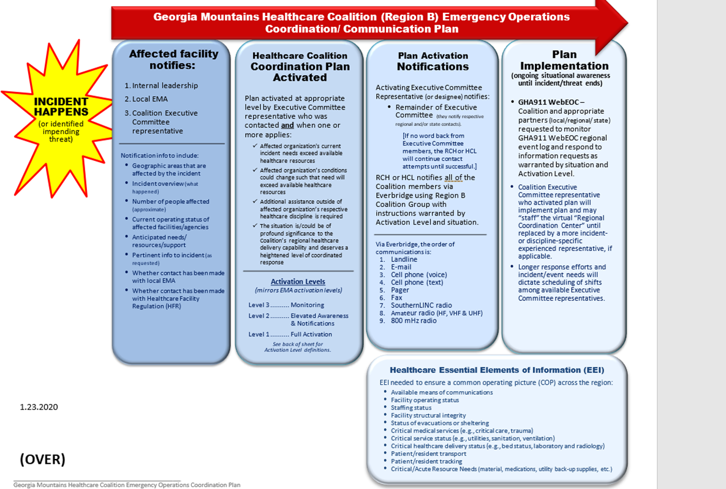

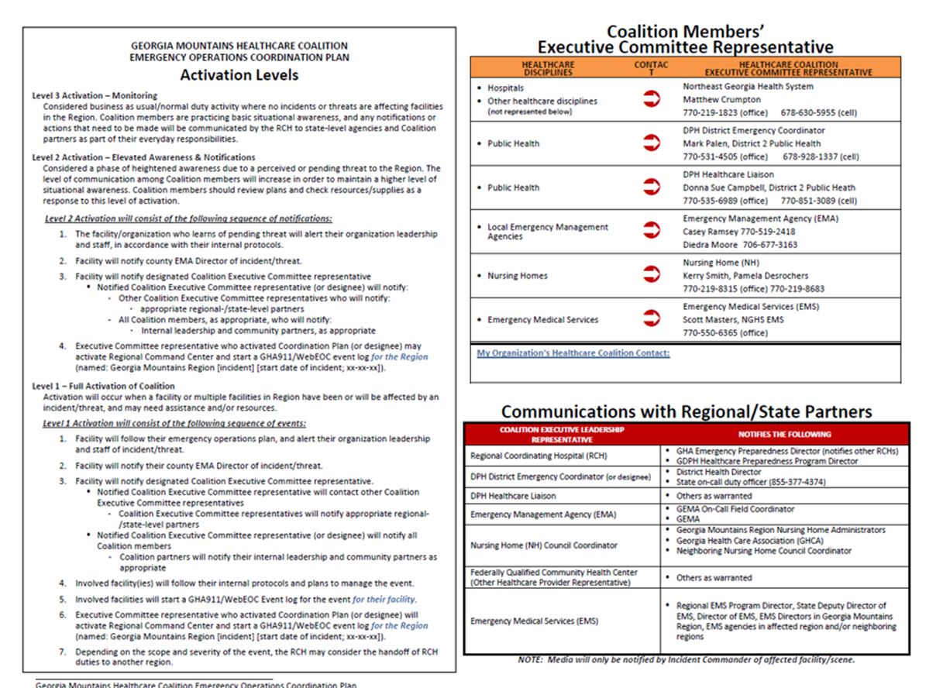

Appendix D: WebEOC Event Log – TTX
Exercise - 2021 Region B - Severe Weather Regional TableTop Exercise - April 2021
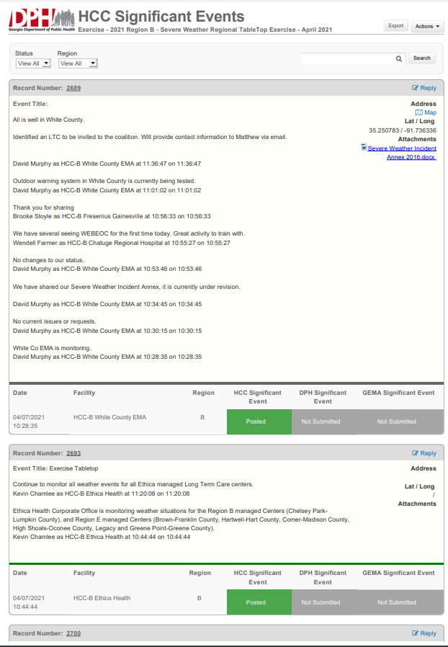
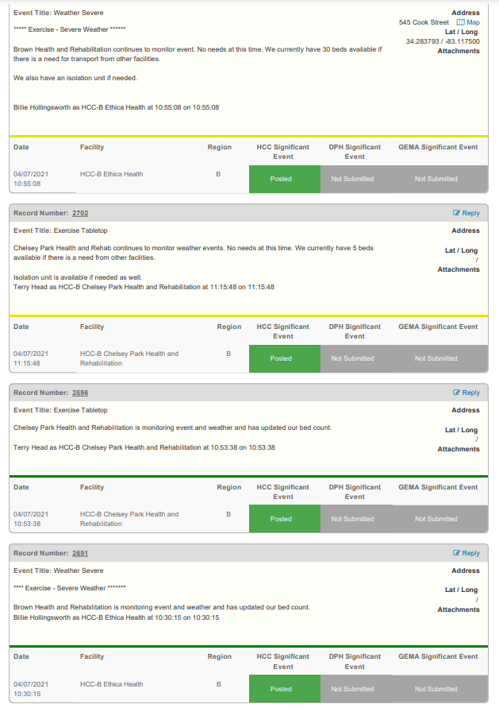
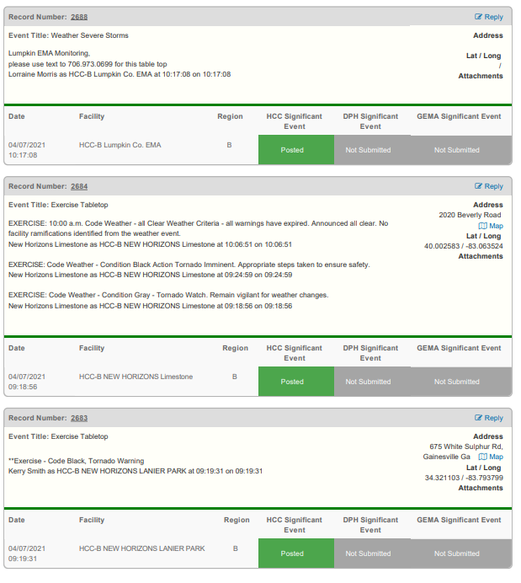

Appendix E: EverBridge Messages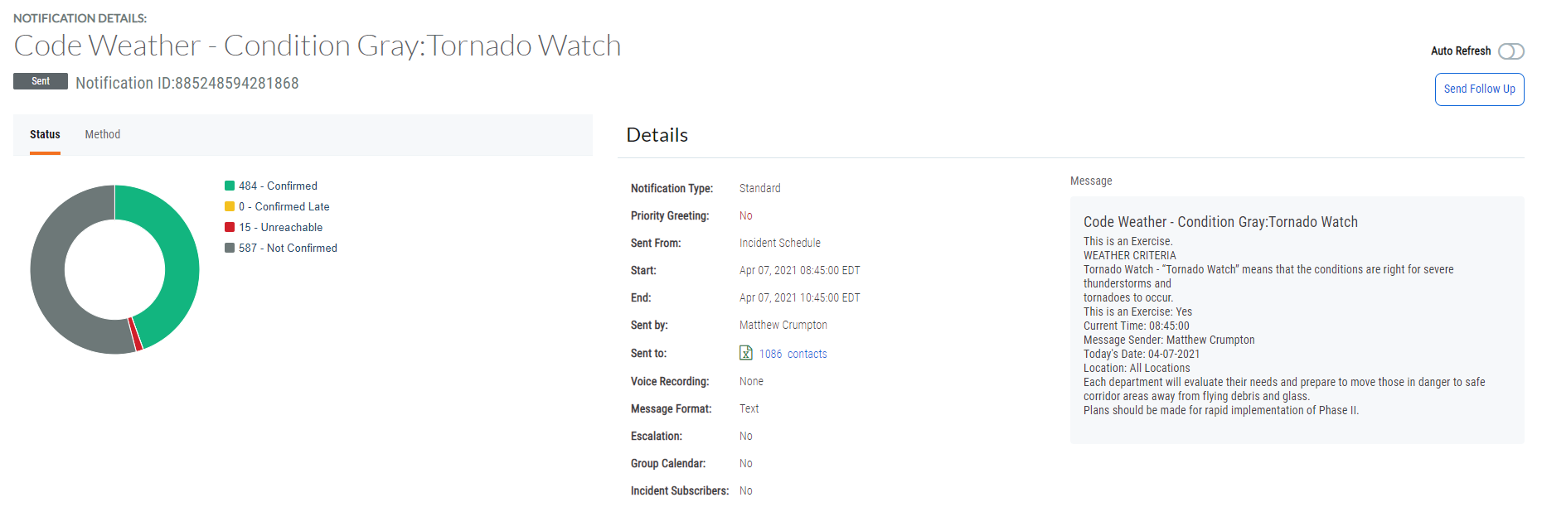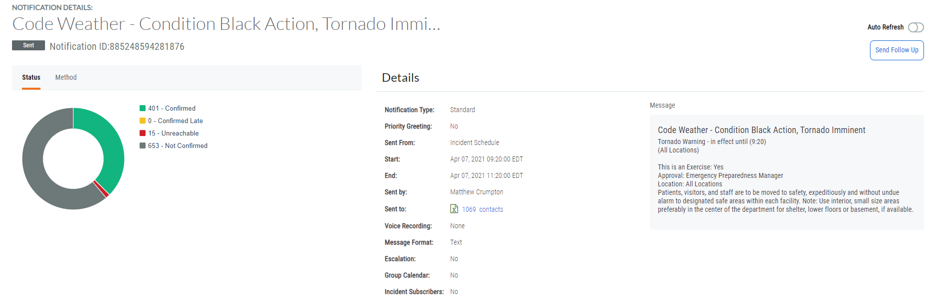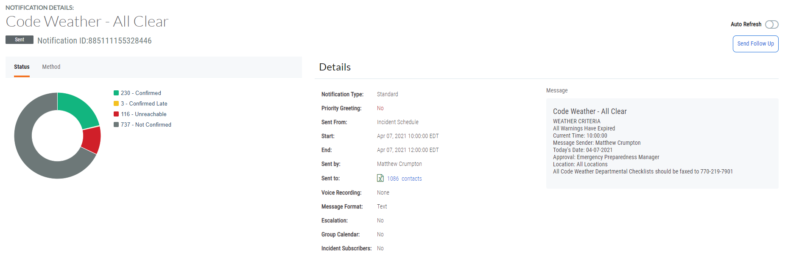
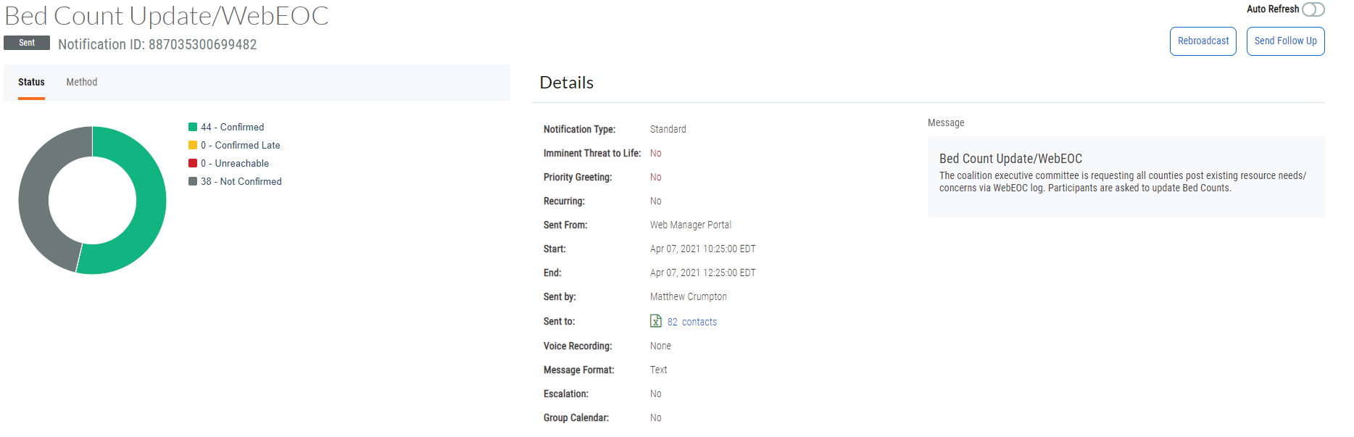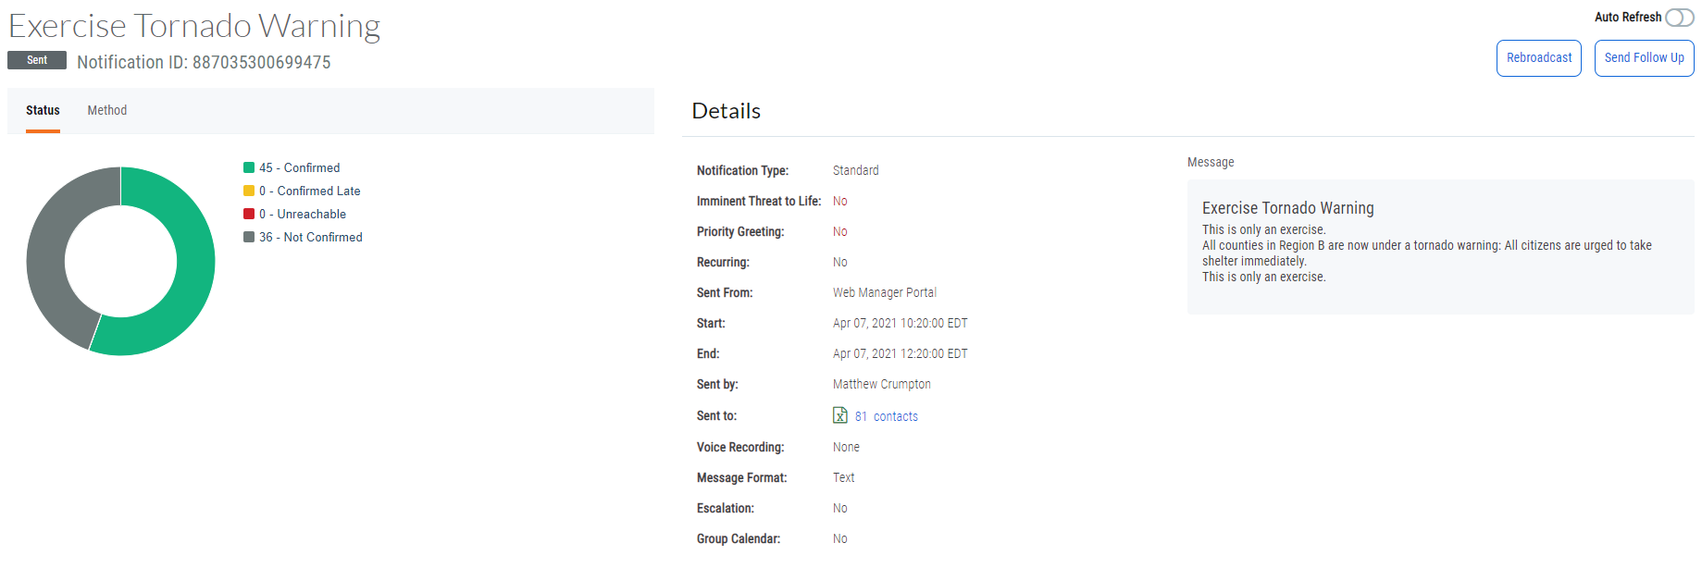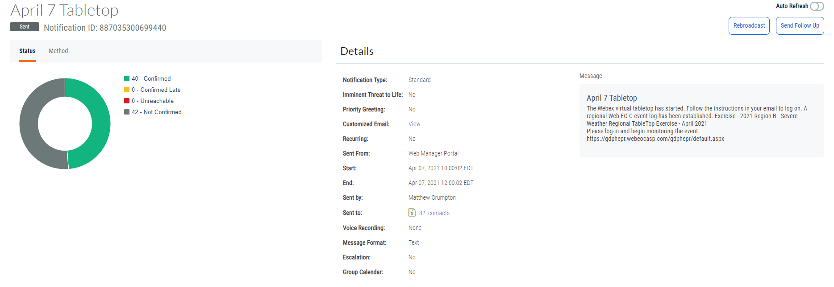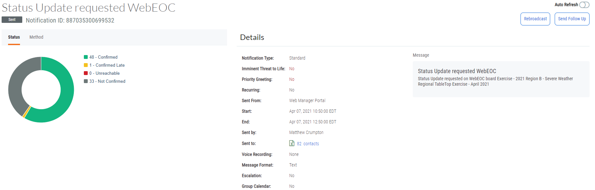

Appendix F: Acronyms
Acronym | Meaning
AAR | After Action Report
ARES | Amateur Radio Emergency Service
CHOA | Children's Healthcare of Atlanta
CC | Command Center
DPS | Public Safety Department
EMA | Emergency Management Agency
EMS | Emergency Medical Services
EOC | Emergency Operations Center
EOP | Emergency Operations Plan
EPD | Environmental Protection Division
EPT | Exercise Planning Team
ESAR-VHP | Emergency System for Advance Registration of Volunteer Health Professionals
ESF | Emergency Support Function
FSE | Full Scale Exercise
FQHC | Federally Qualified Health Center
GAPHC | Georgia Association for Primary Health Care
GDBHDD | Georgia Department of Behavioral Health and Developmental Disabilities
GDPH | Georgia Department of Public Health
GEMA | Georgia Emergency Management Agency
GHA | Georgia Hospital Association
GHCA | Georgia Health Care Association
HCL | Healthcare Liaison
HICS | Hospital Incident Command System
HSEEP | Homeland Security Exercise Evaluation Program
HVA | Hazard Vulnerability Assessment
HVAC | Heating, Ventilation, and Air Conditioning
ICS | Incident Command System
ISC | Internal Surge Capacity
IT | Information Technology
JIC | Joint Information Center
LE | Law Enforcement
LEPC | Local Emergency Planning Committee
LTC | Long Term Care
MOU | Memorandum of Understanding
MSEL | Master Scenario Event List
NIMS | National Incident Management System
PAPRs | Powered Air Purifying Respirator
PH | Public Health
PIO | Public Information Officer
PPE | Personal Protective Equipment
RACES | Radio Amateur Civil Emergency Service
RCH | Regional Coordinating Hospital
SERVGA | State Emergency Registry of Volunteers of Georgia
SitMan | Situation Manual
SME | Subject Matter Expert
TTX | Tabletop Exercise

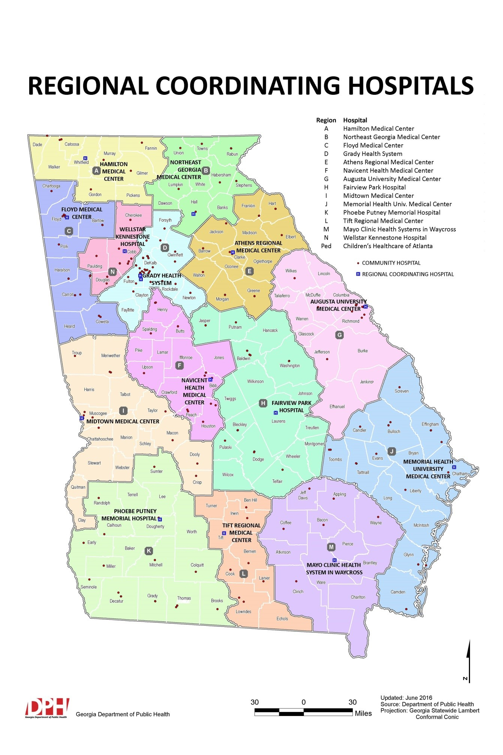
Appendix G: Regional Coordinating Hospital Area Map

Appendix H: Public Health Districts Map
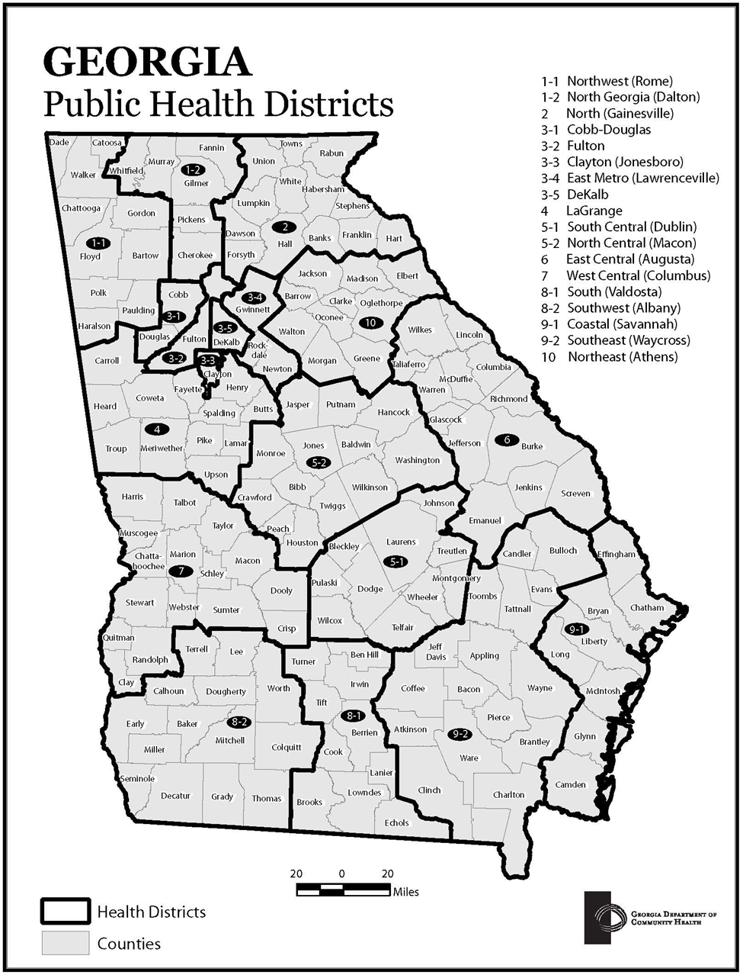

Appendix I: Emergency Medical Service Regions Map
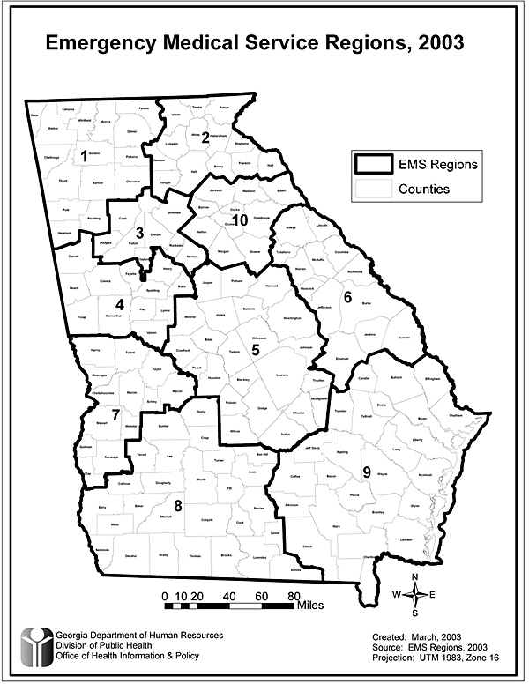

Appendix J: GEMA Regions Map
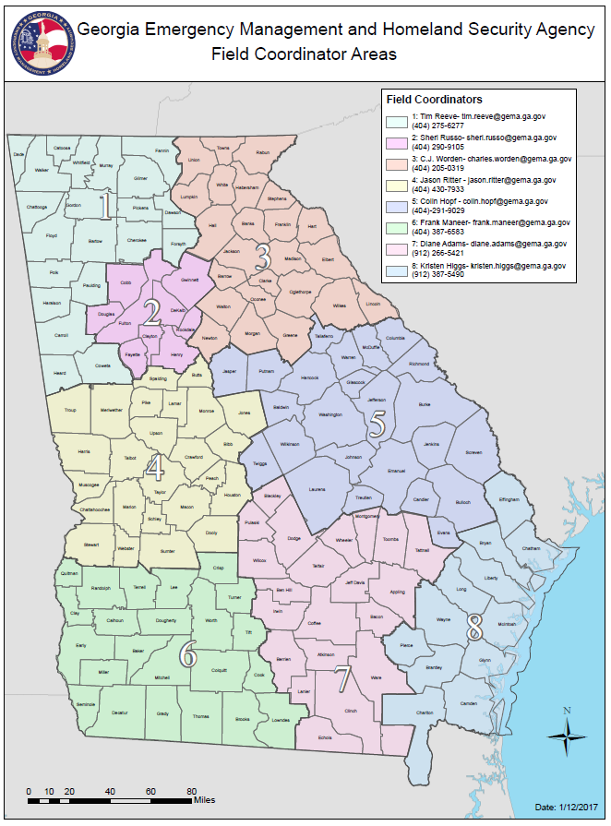

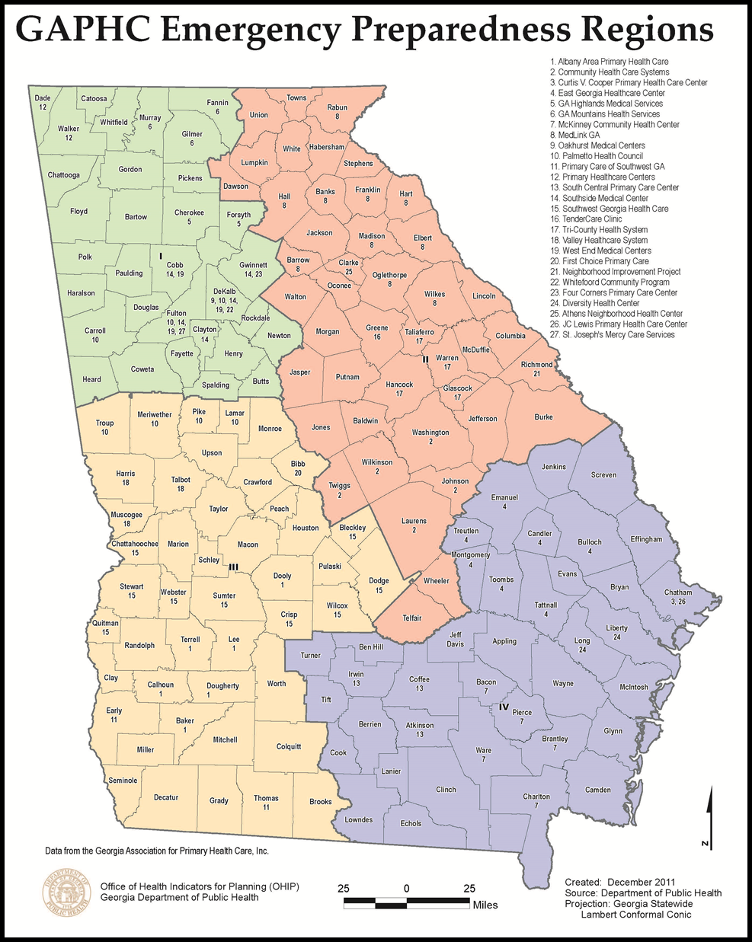
Appendix K: Georgia Health Care Association Council Map
(Nursing Homes)

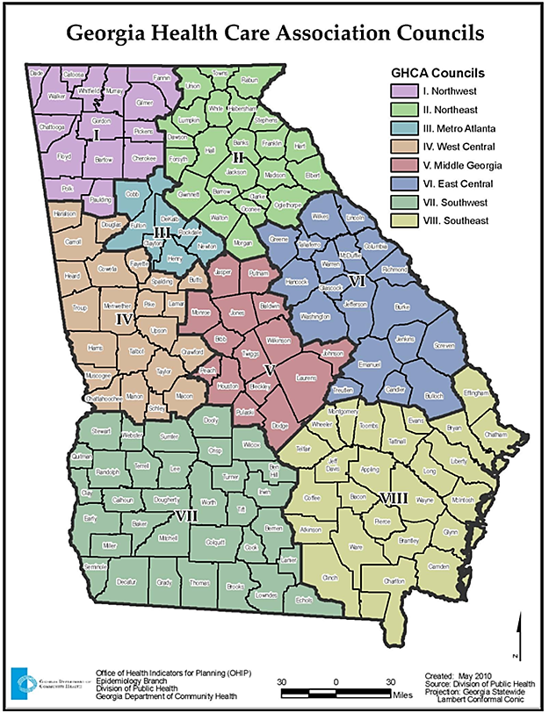
Appendix L: GAPHC Community Health Centers Map

Appendix M: GDBHDD Regional Map
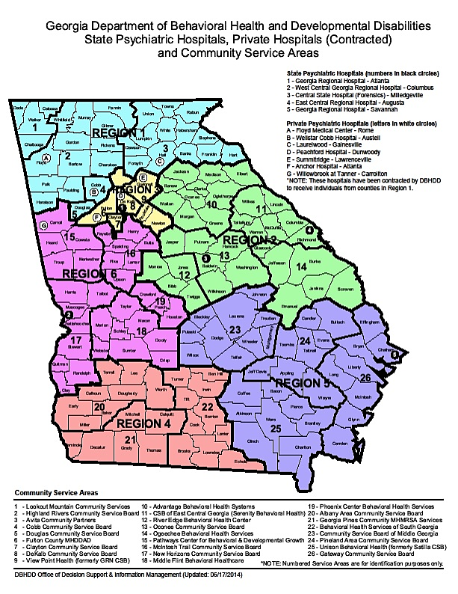

Appendix N: Georgia ARES Districts
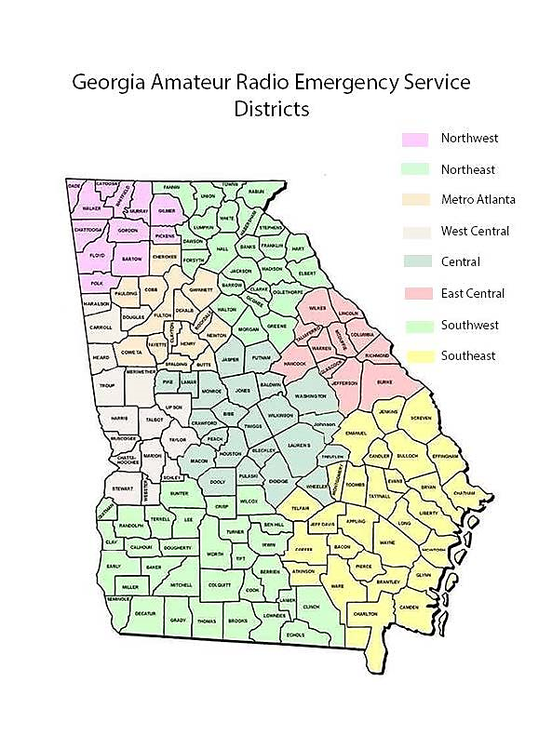

Appendix O: Government Emergency Telecommunications Service (GETS) Fact Sheet
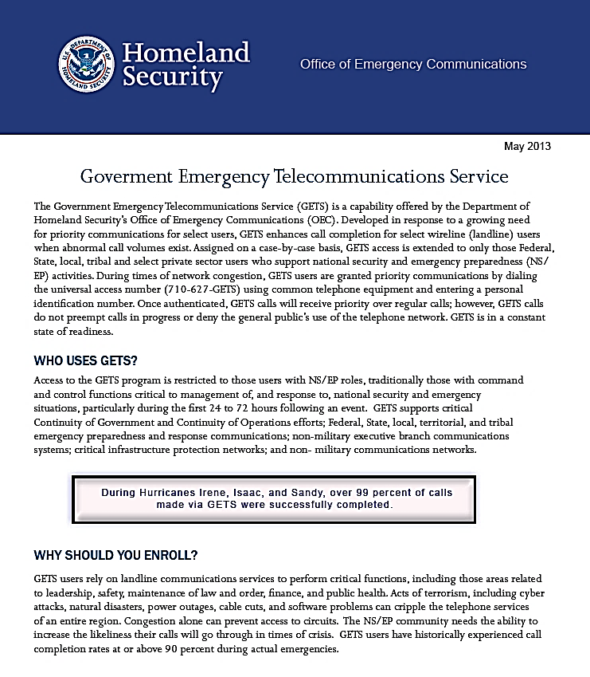
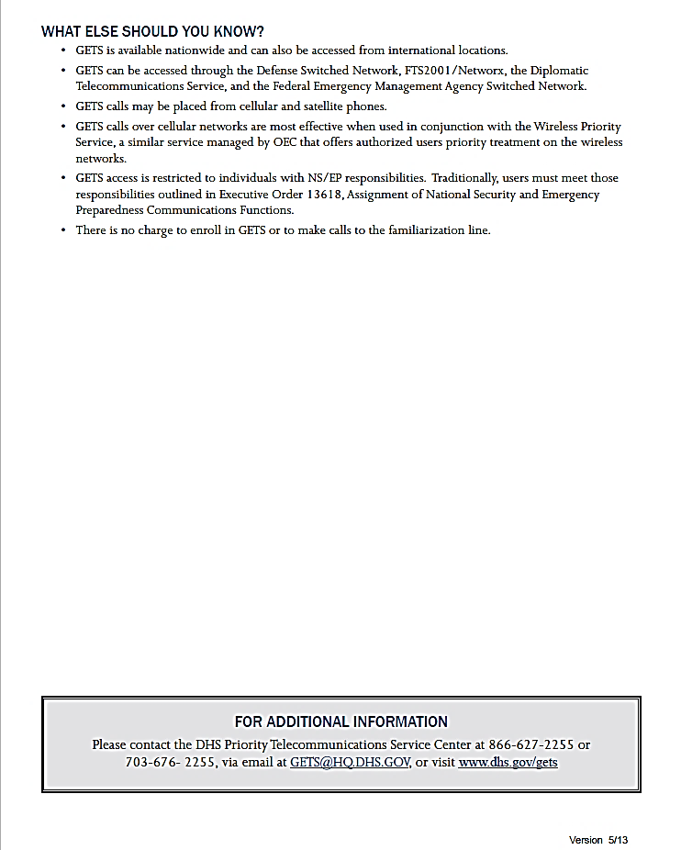

Appendix P: Wireless Priority Service (WPS) Fact Sheet
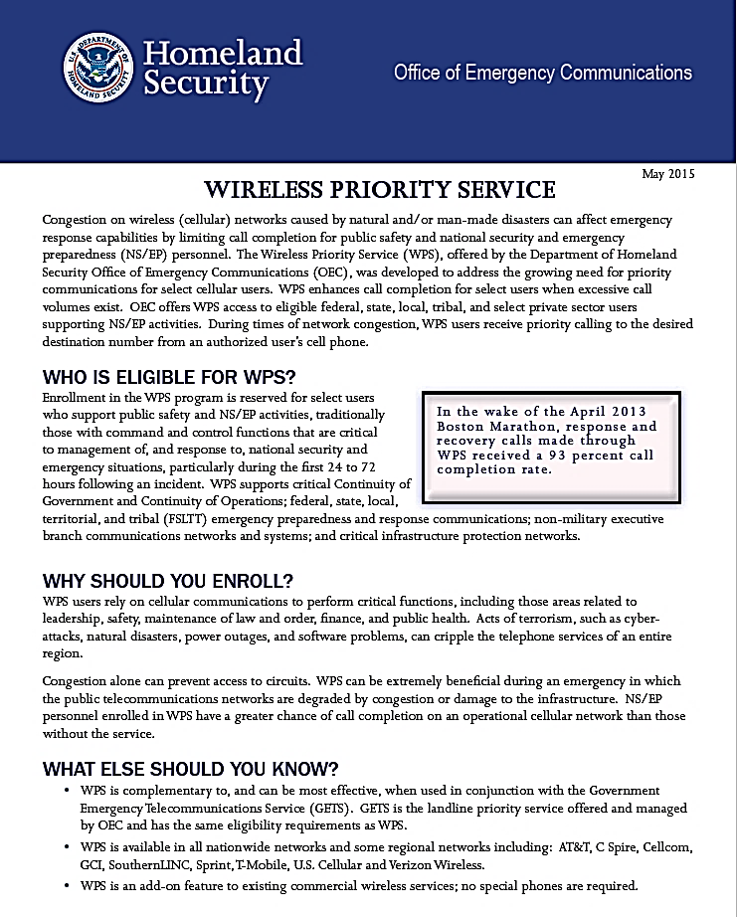
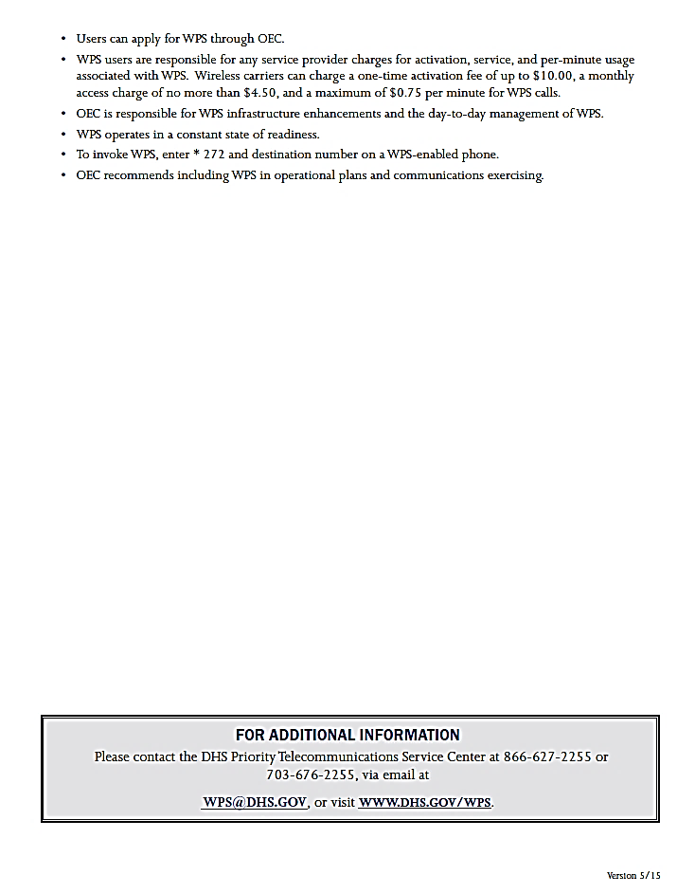

Appendix Q: Role of Specialty Coordinating Hospital
Children’s Healthcare of Atlanta (CHOA) has contracted with the Georgia Hospital Association (GHA) to act as the Specialty Coordinating Hospital (SCH) for pediatrics with the state of Georgia. In the event of a disaster, CHOA will assist facilities and regions with pediatric patient needs. CHOA Transfer Center can facilitate the acceptance of pediatric patients.
If the scope of the event exceeds the resources of CHOA, we will work with those facilities within Georgia that have pediatric inpatient capabilities for patient placement. CHOA’s is also a signatory to the Southeastern Regional Pediatric Disaster Network and is in contact with numerous pediatric hospitals across the Southeast (Tennessee, North Carolina, South Carolina, Florida, Kentucky, Alabama, and Mississippi). This organization has a memorandum of understanding to support each other in the event of a disaster involving pediatrics.
For assistance with pediatric patient placement, please call the
Children’s Healthcare of Atlanta Transfer Center
404-785-7778 or 1-888-785-7778

Additional responsibilities of the Specialty Coordinating Hospital (SCH)
Children’s Healthcare of Atlanta will:
- Provide technical assistance for hospitals in the development of plans and exercises as well as during real world emergencies upon request.
- Assistance may include providing additional staffing, sharing expertise and distribution of specialty care supplies and equipment through mutual aid during a disaster or evacuation.
- Participate in regional drills to offer pediatric expertise and to encourage pediatric patients to be included in drill casualties to better prepare for world events
If you need more information on Children’s role as the SCH for pediatrics, please contact Karen Hill at 404-785-6503.
Children’s Healthcare of Atlanta Overview
- CHOA is comprised of three (3) separate hospitals: Egleston, Scottish Rite and Hughes Spalding.
  - Egleston is the only designated Level 1 Pediatric Trauma Center in the state.
  - Scottish Rite is the only designated Level 2 Pediatric Trauma Center in the state.
  - Hughes Spaulding has Pediatric Emergency Department and pediatric general care capabilities.
- Between the 3 campuses, CHOA has over 500 licensed pediatric beds!
Additional CHOA Contacts

- Trauma intake line for EMS:
  - 404-785-5082 or
  - State HEAR or
  - MED Channel 2 or 3

- Children’s Transport
  - 404-785-6540 or
  - 1-800-325-6540

- Currently this includes 58 pediatric intensive care beds combined in 2 PICU’s, Neonatal Intensive Care Units (NICU) a Cardiac Intensive Care Unit (CICU) and Technology Dependent Unit (TDICU). Egleston has ECMO capabilities as well.
- CHOA has all pediatric sub-specialties and will accept pediatric patients in transfer when beds are available.
CHOA can assist with the transport of patients. CHOA can provide ground transportation with up to 7 ambulances and 1 helicopter. CHOA can also assist with fixed wing transport.

Capability Elements are: Planning, Organization, Equipment, Training, or Exercise.

